THIS IS THE REPORT OF THE PROJECT , AI WAS USED , NOTEPAD AND WORD WAS USED FOR THE CREATION OF THIS REPORT .

THANK YOU//

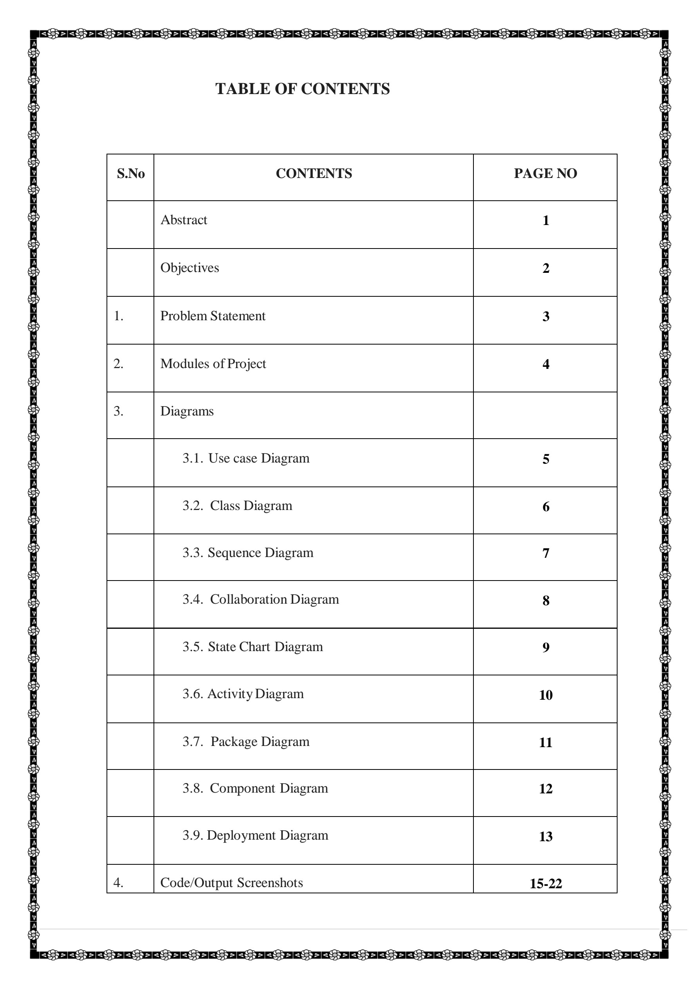



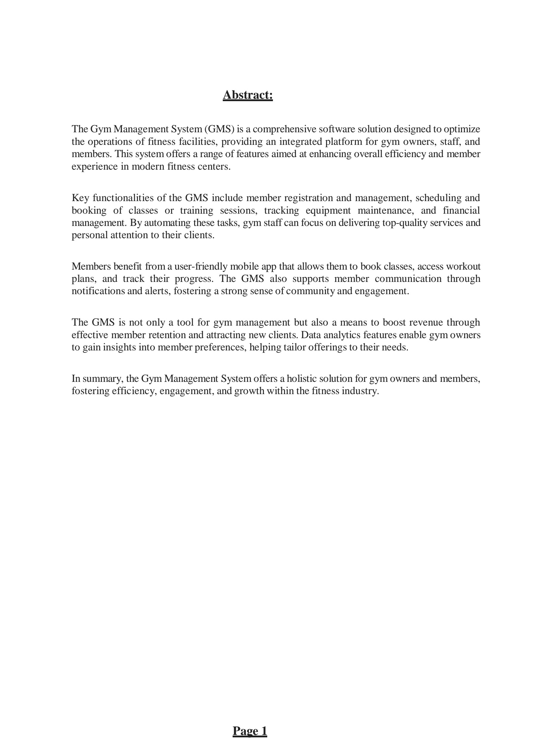

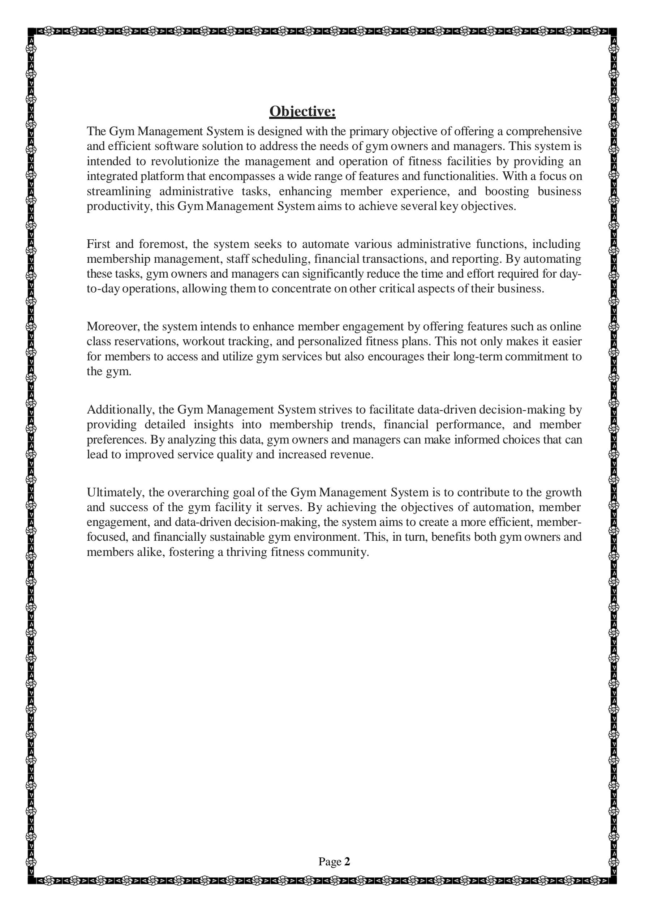

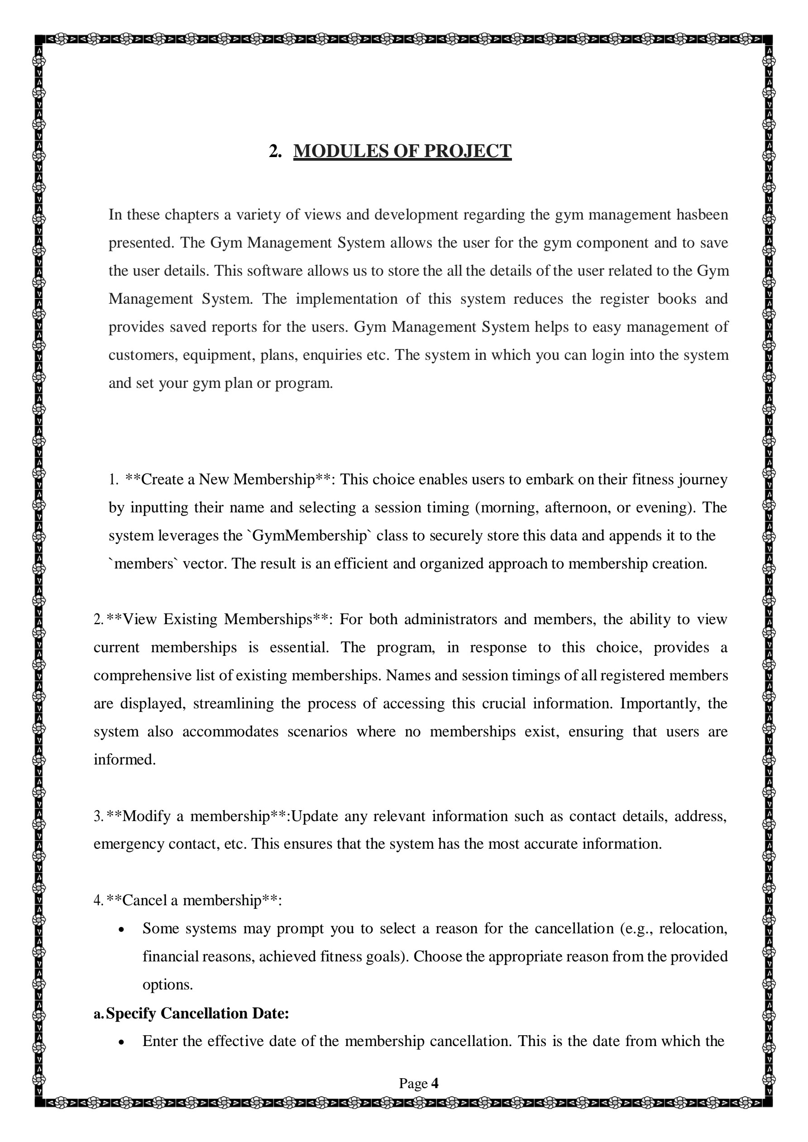



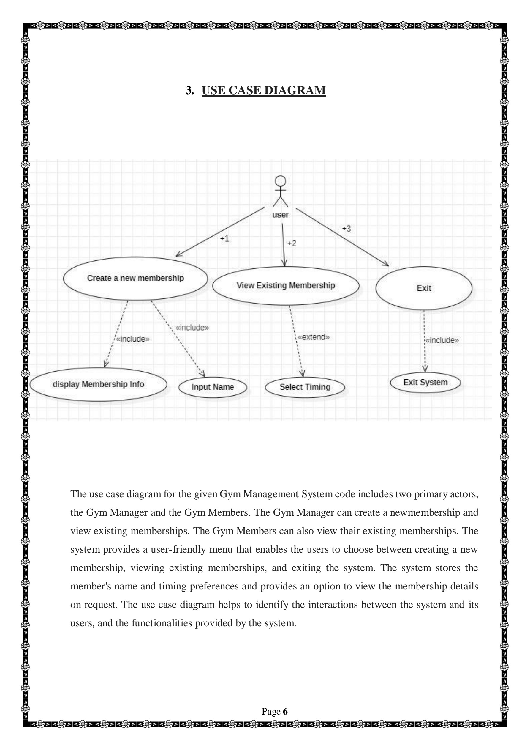

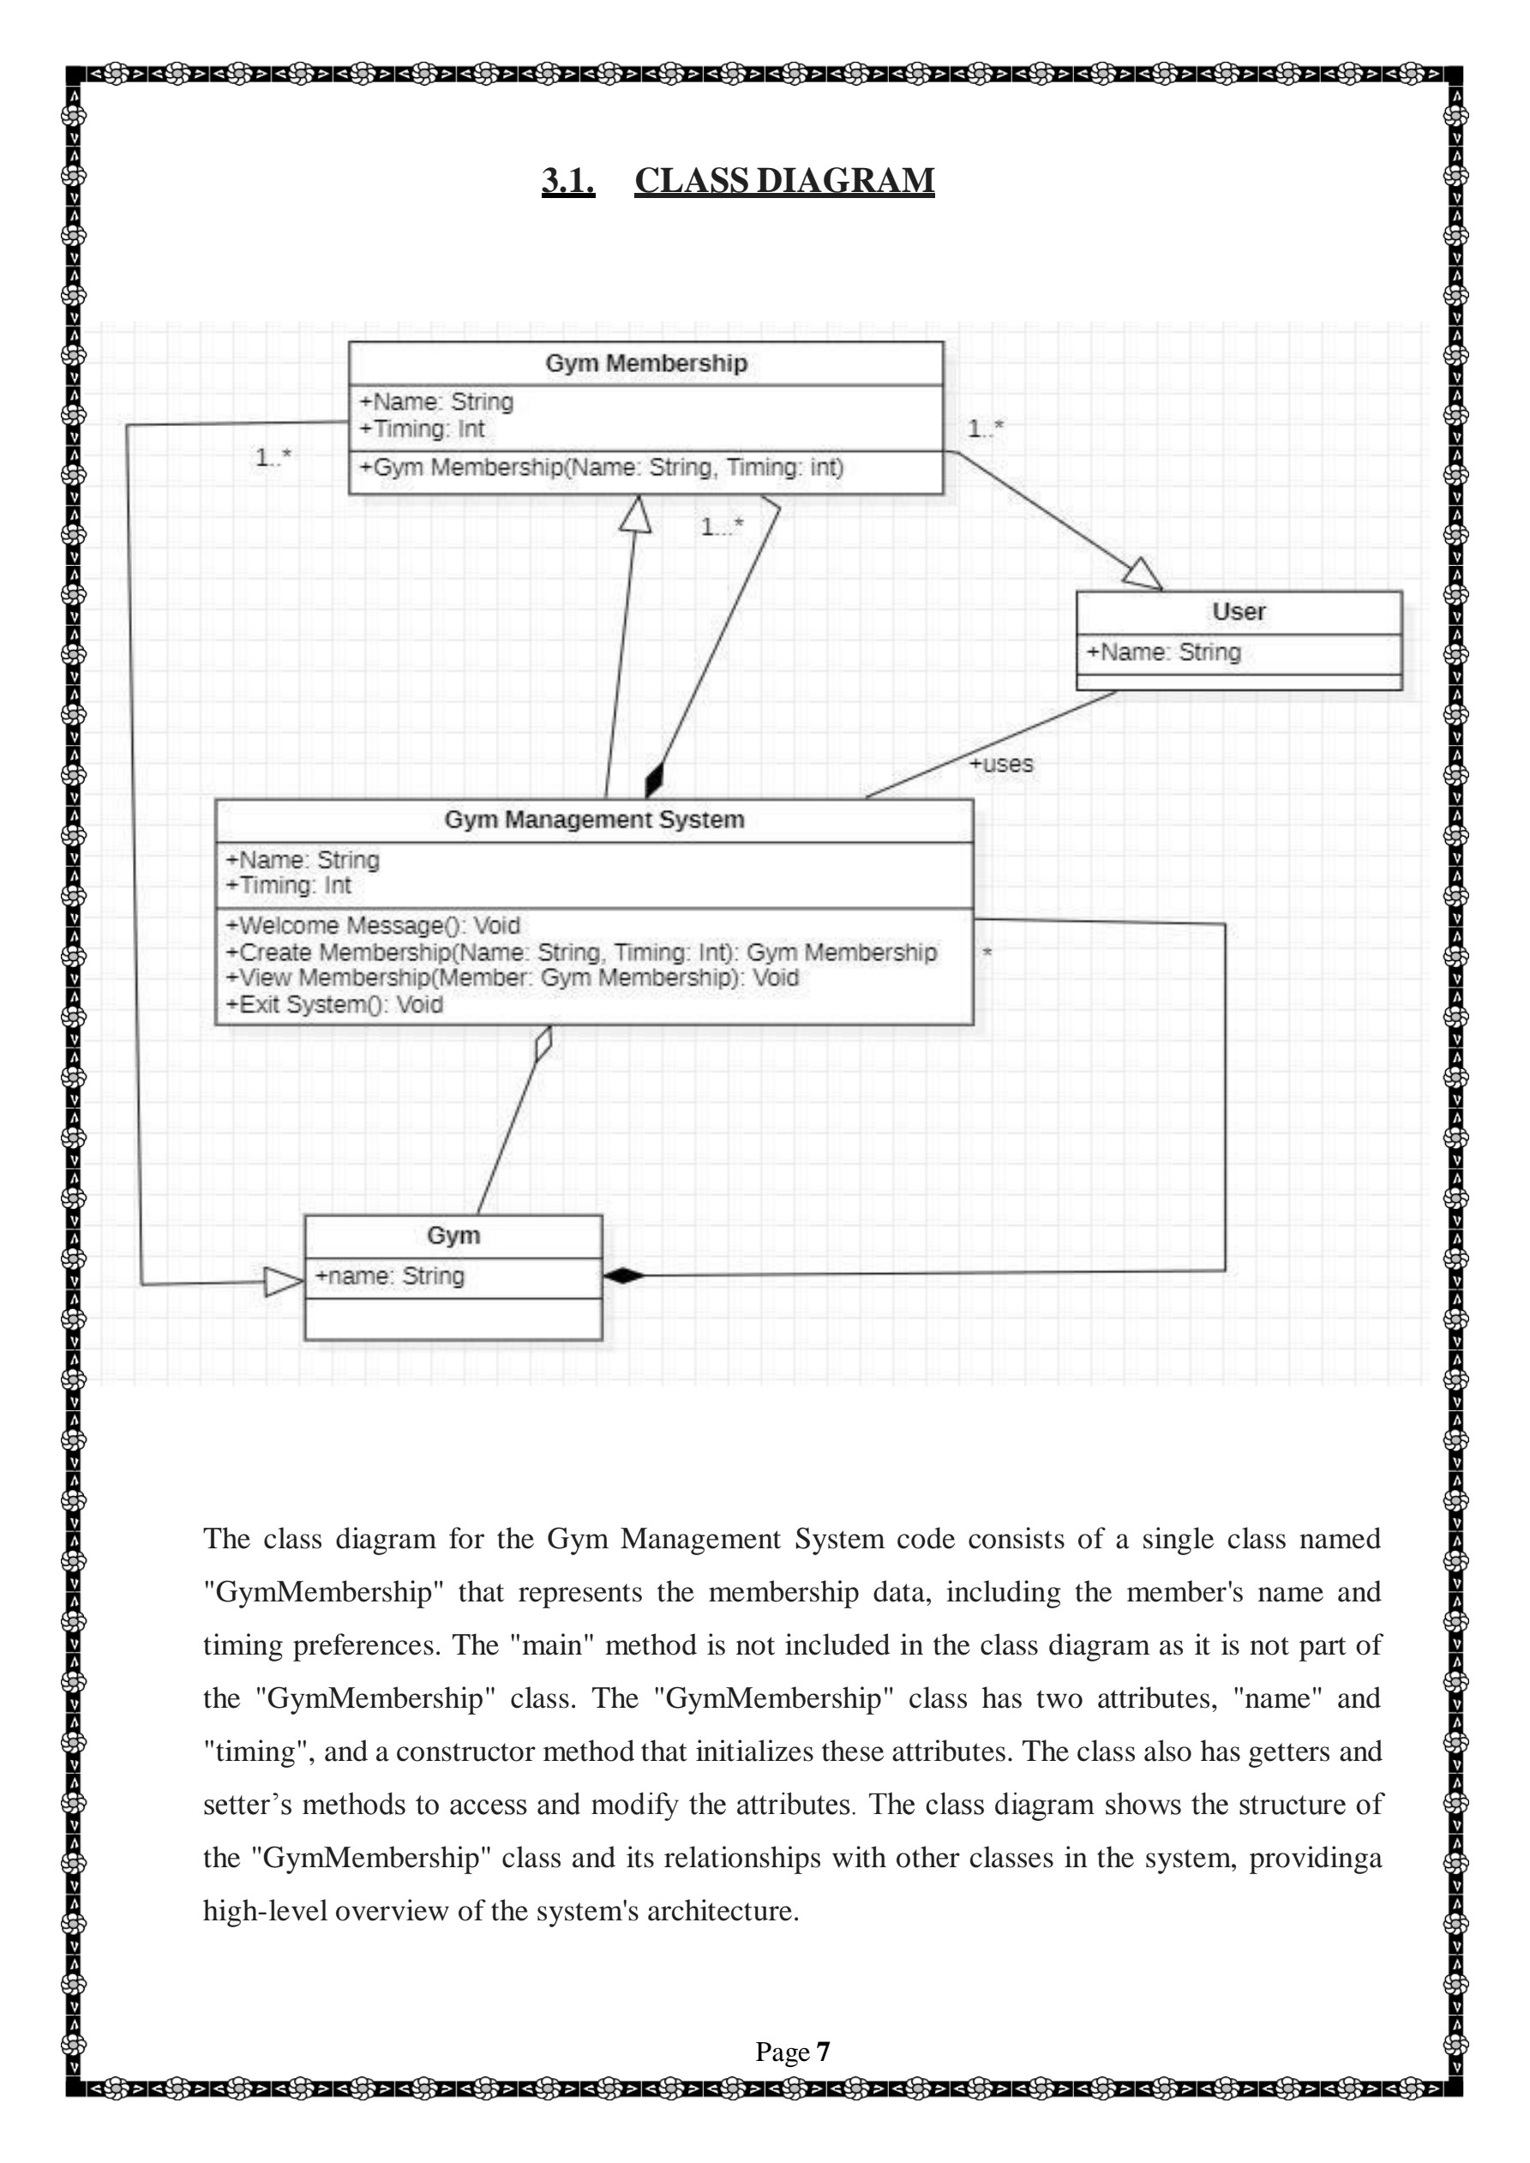

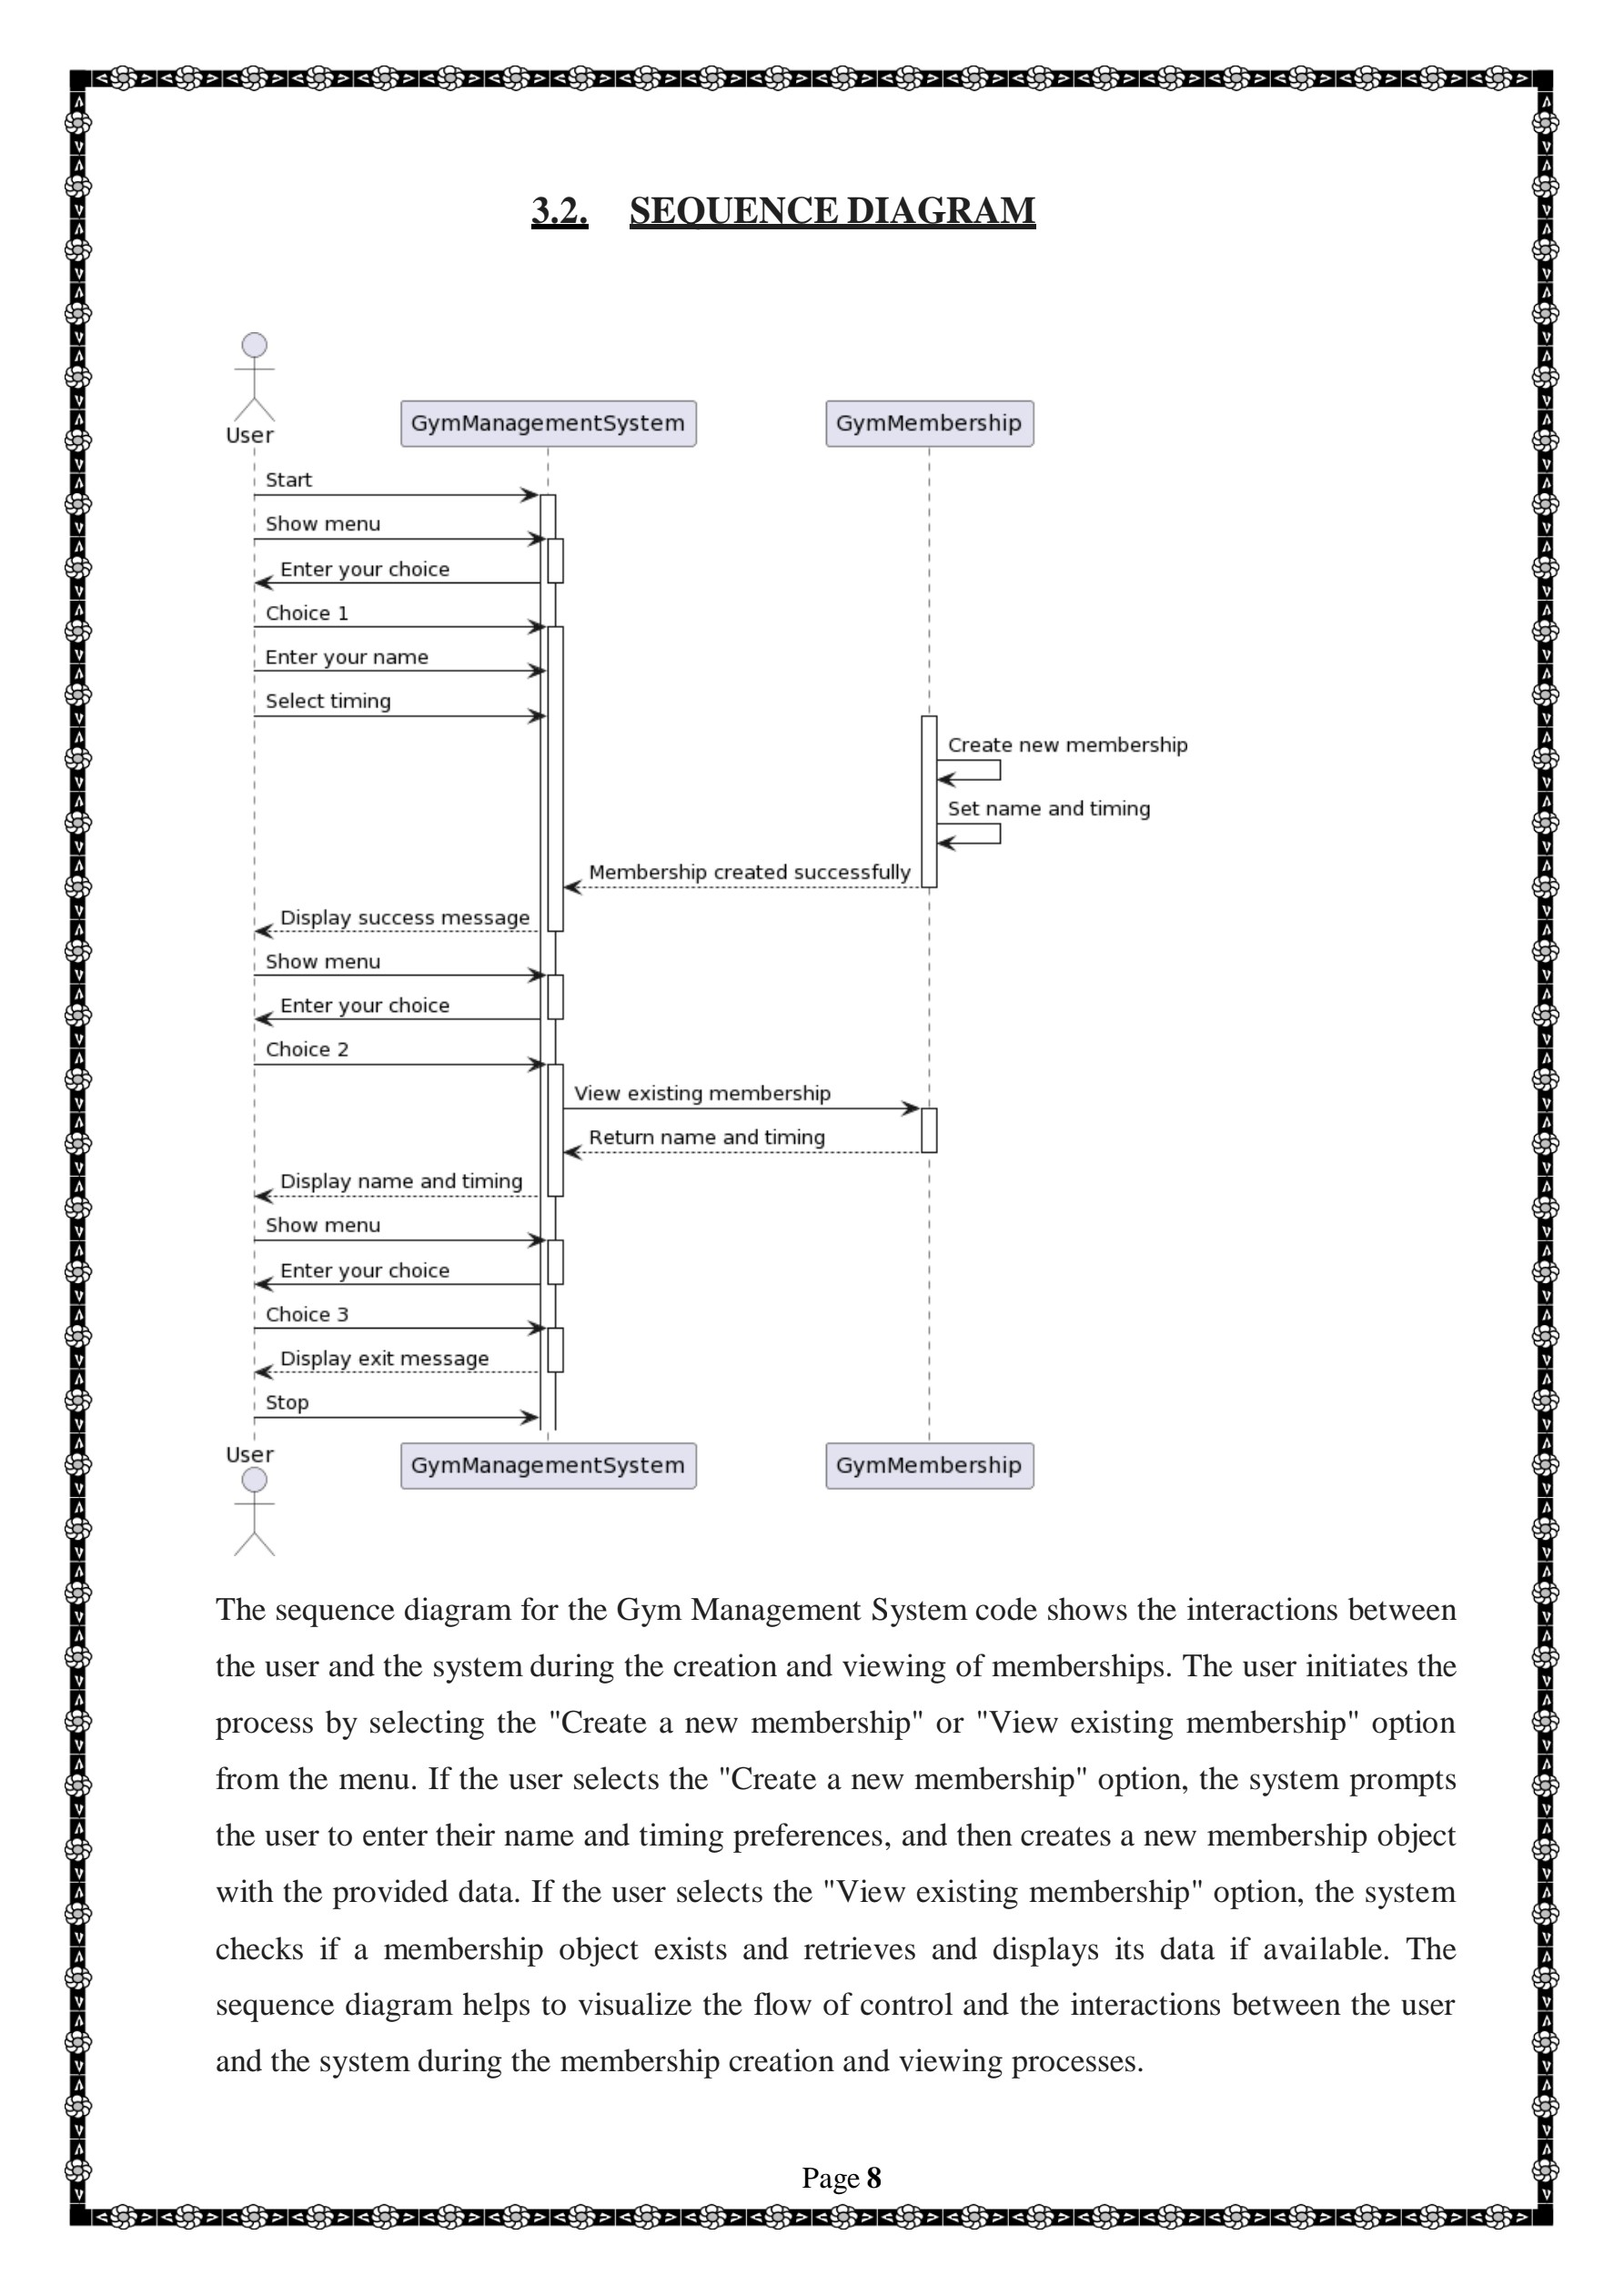

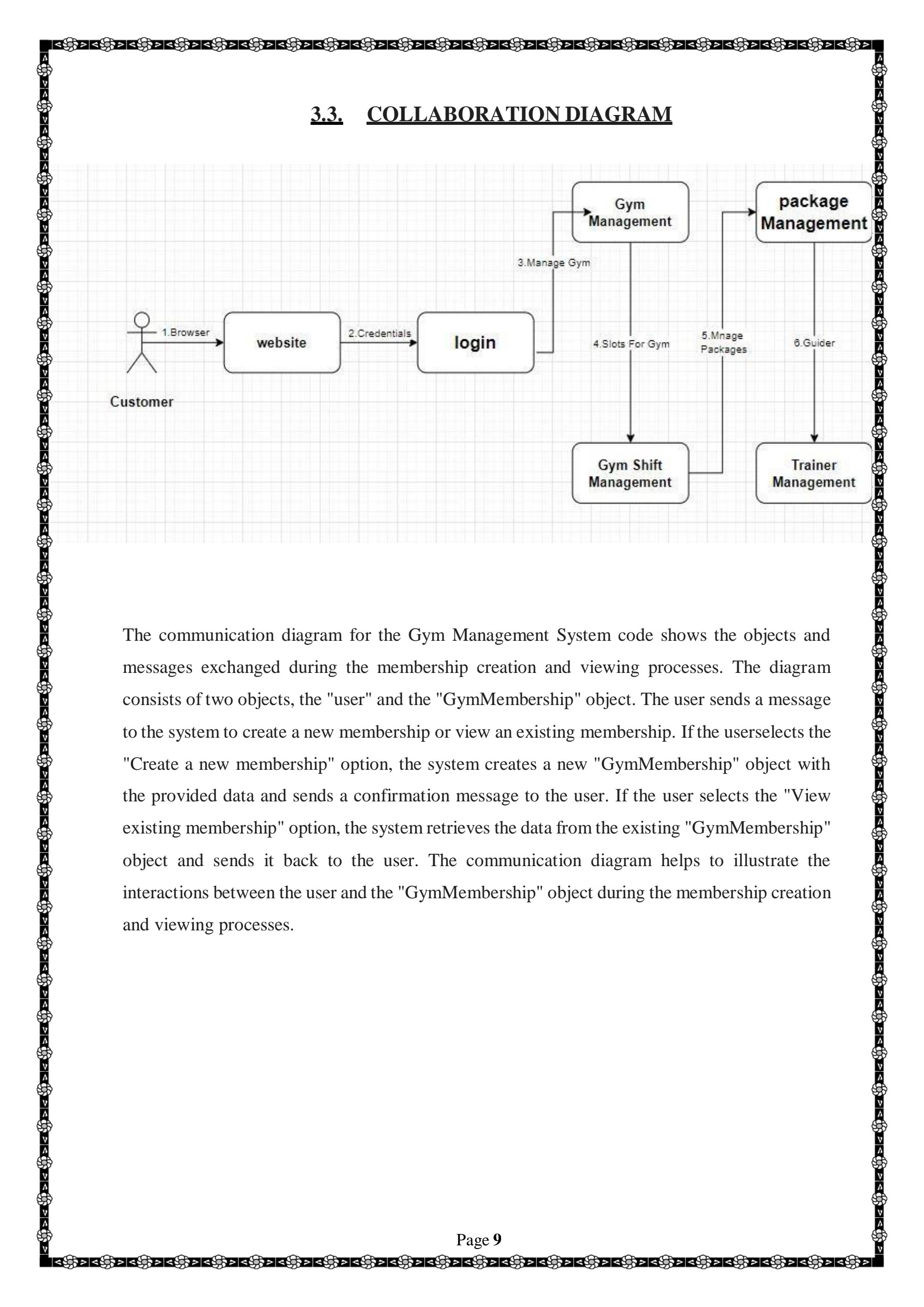

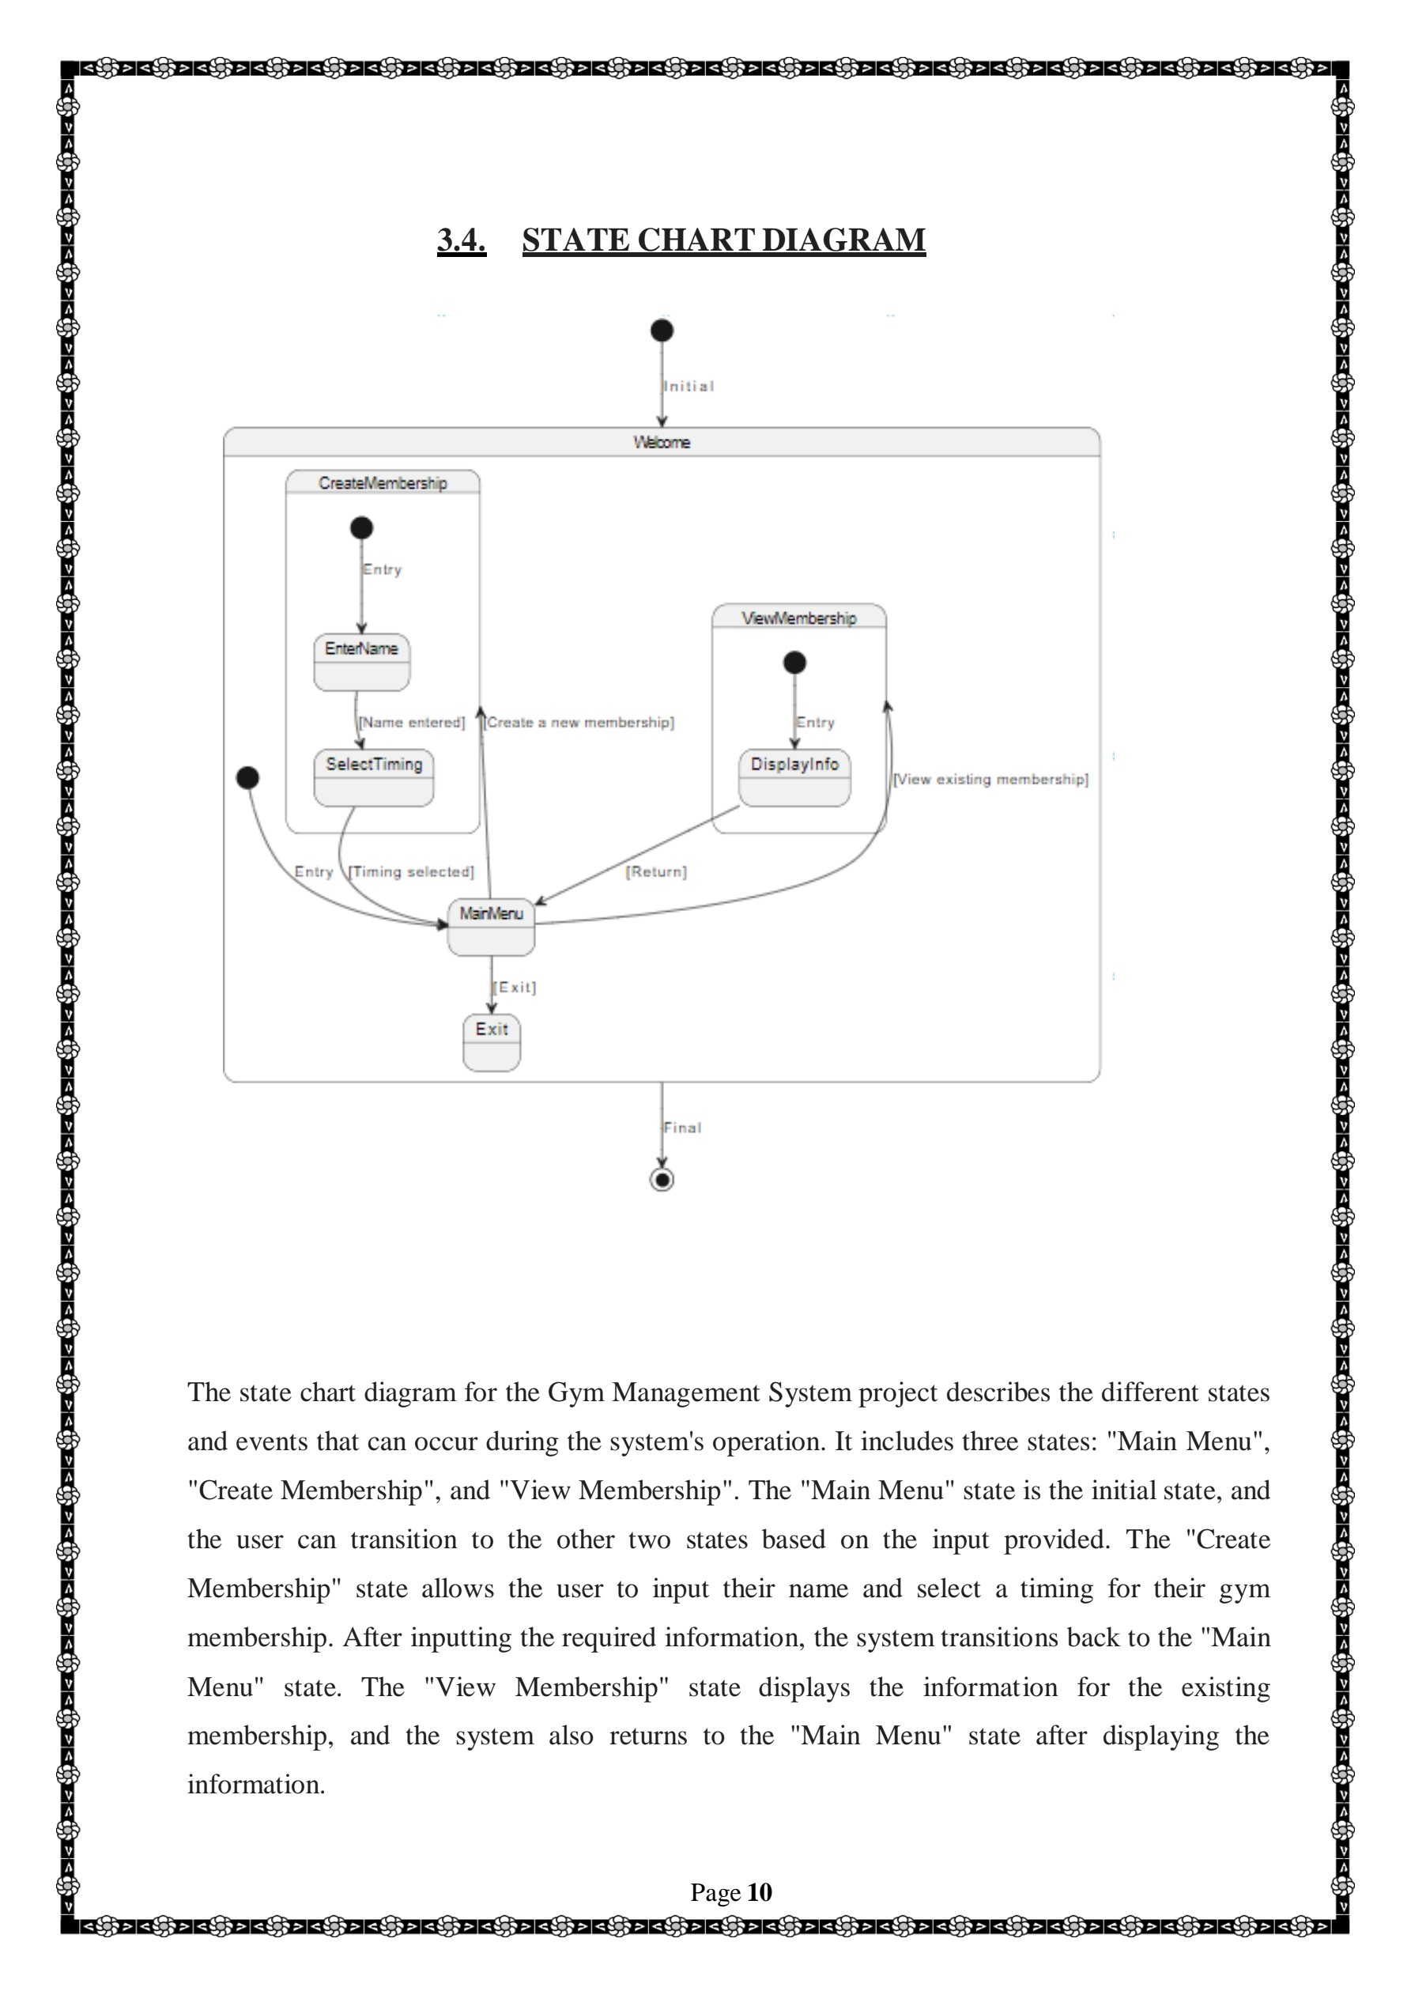

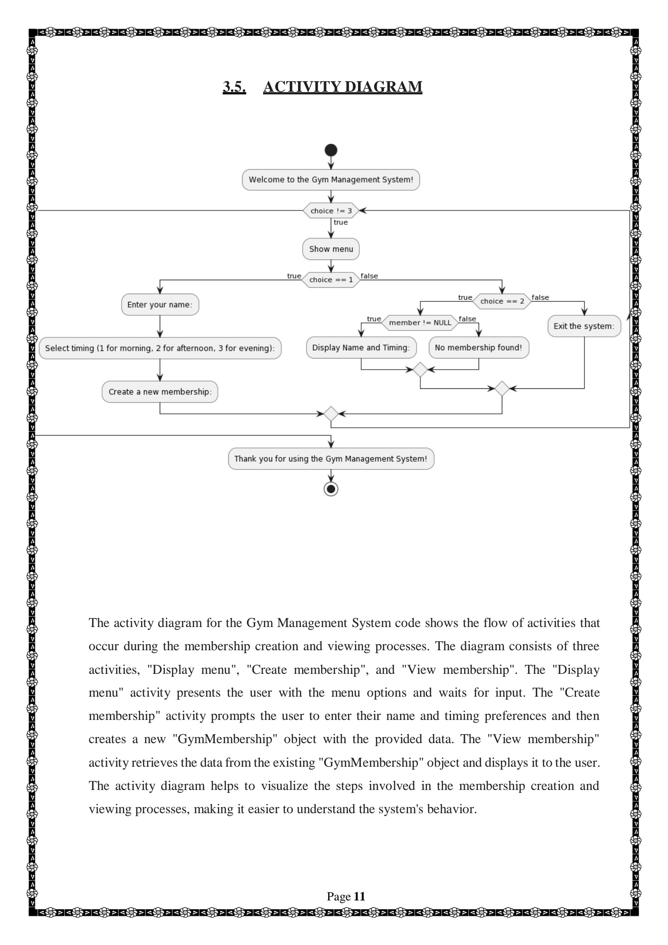

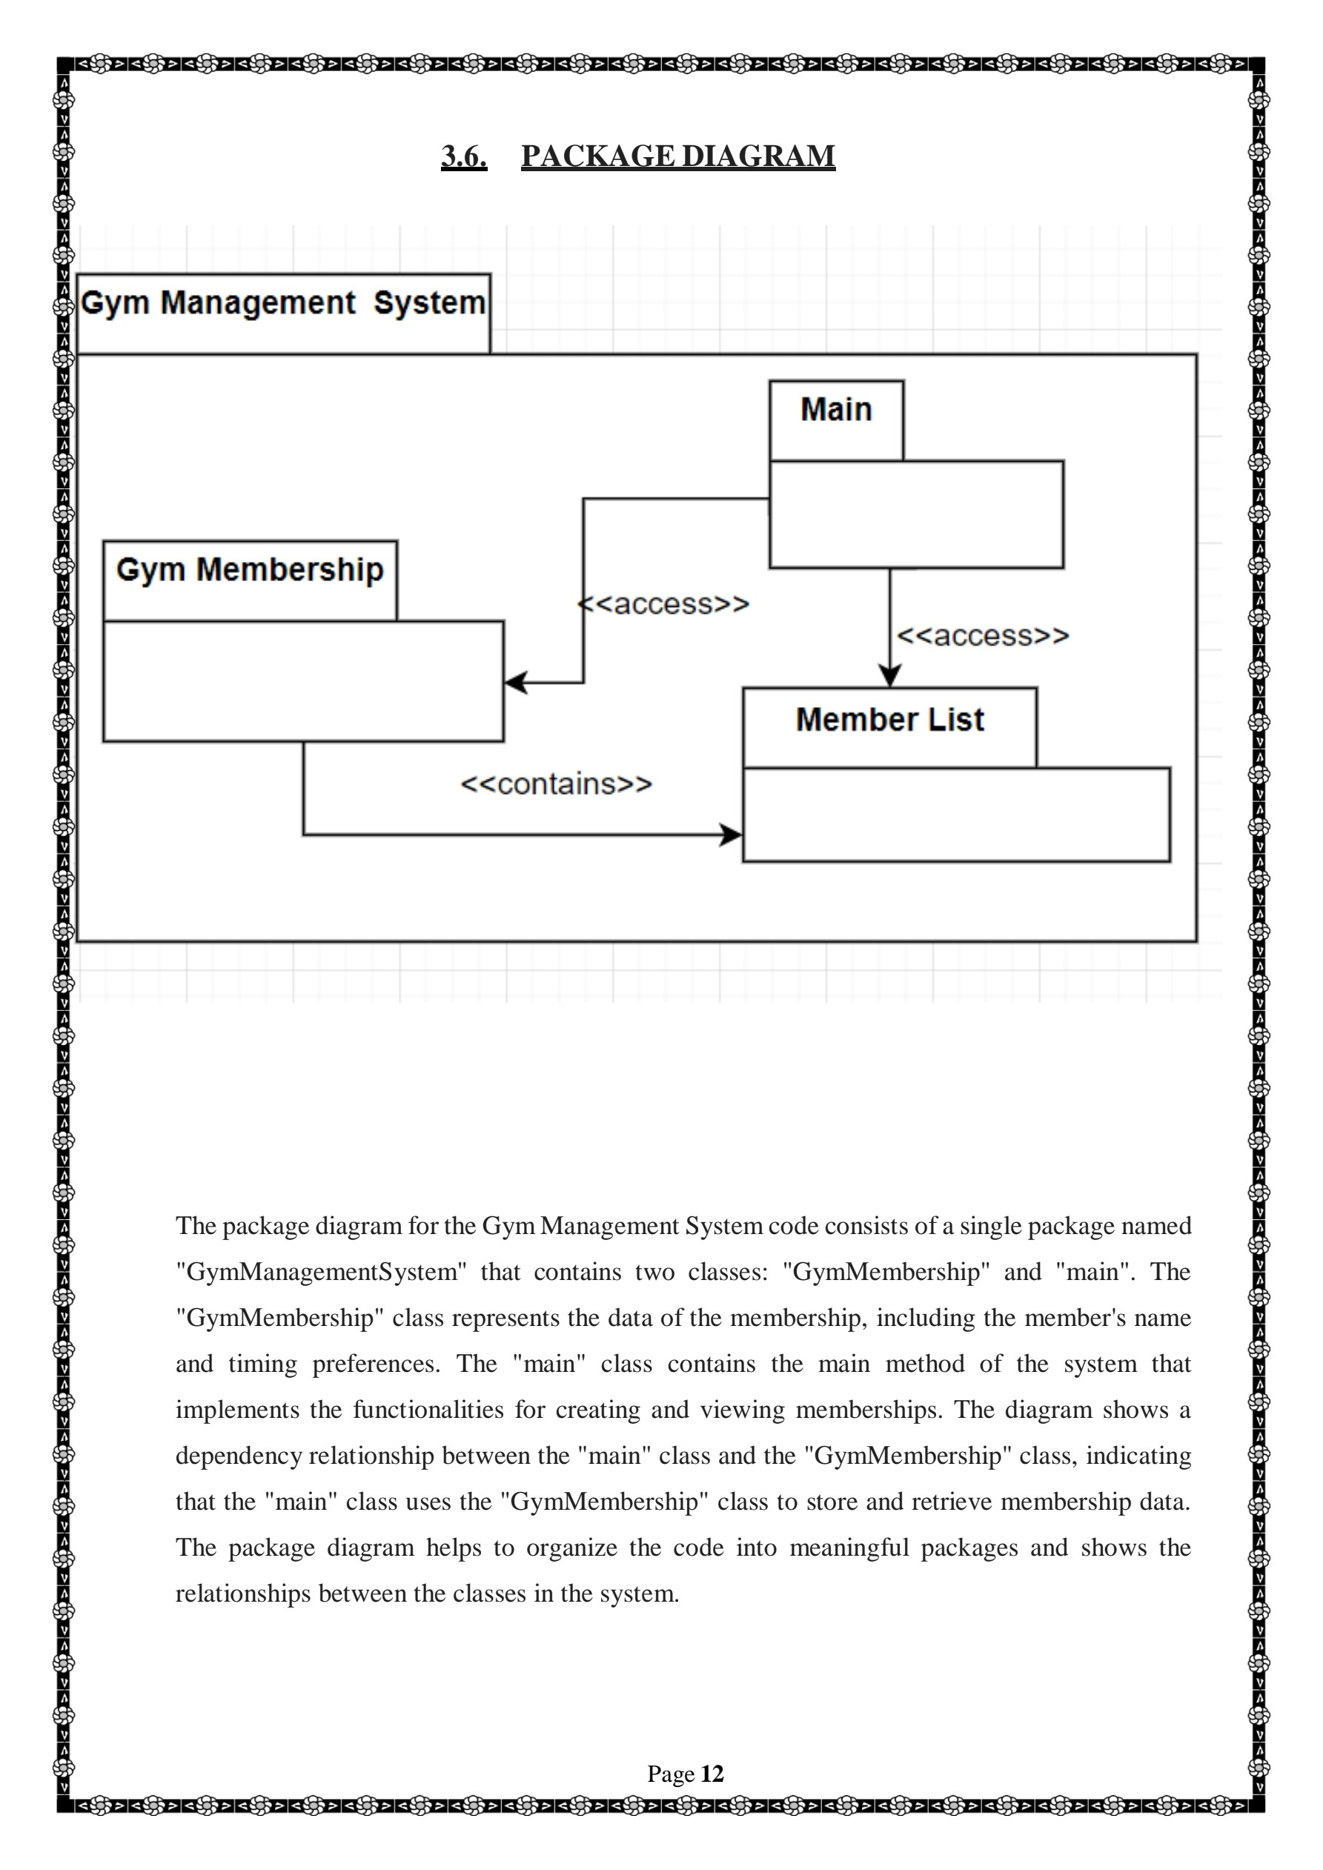

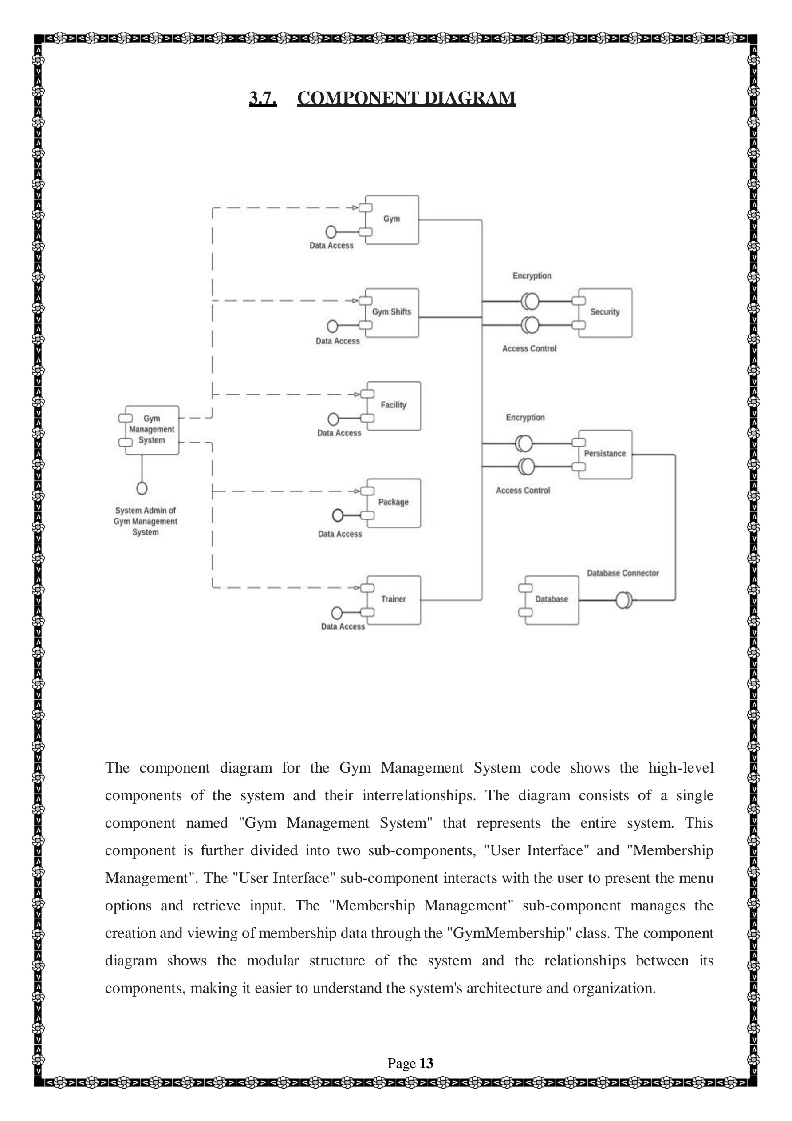

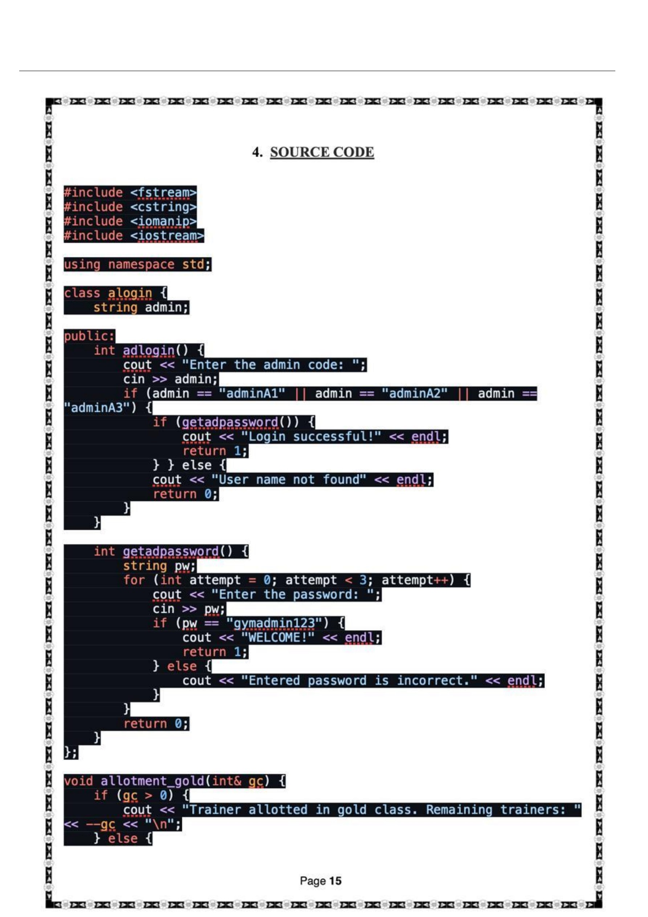

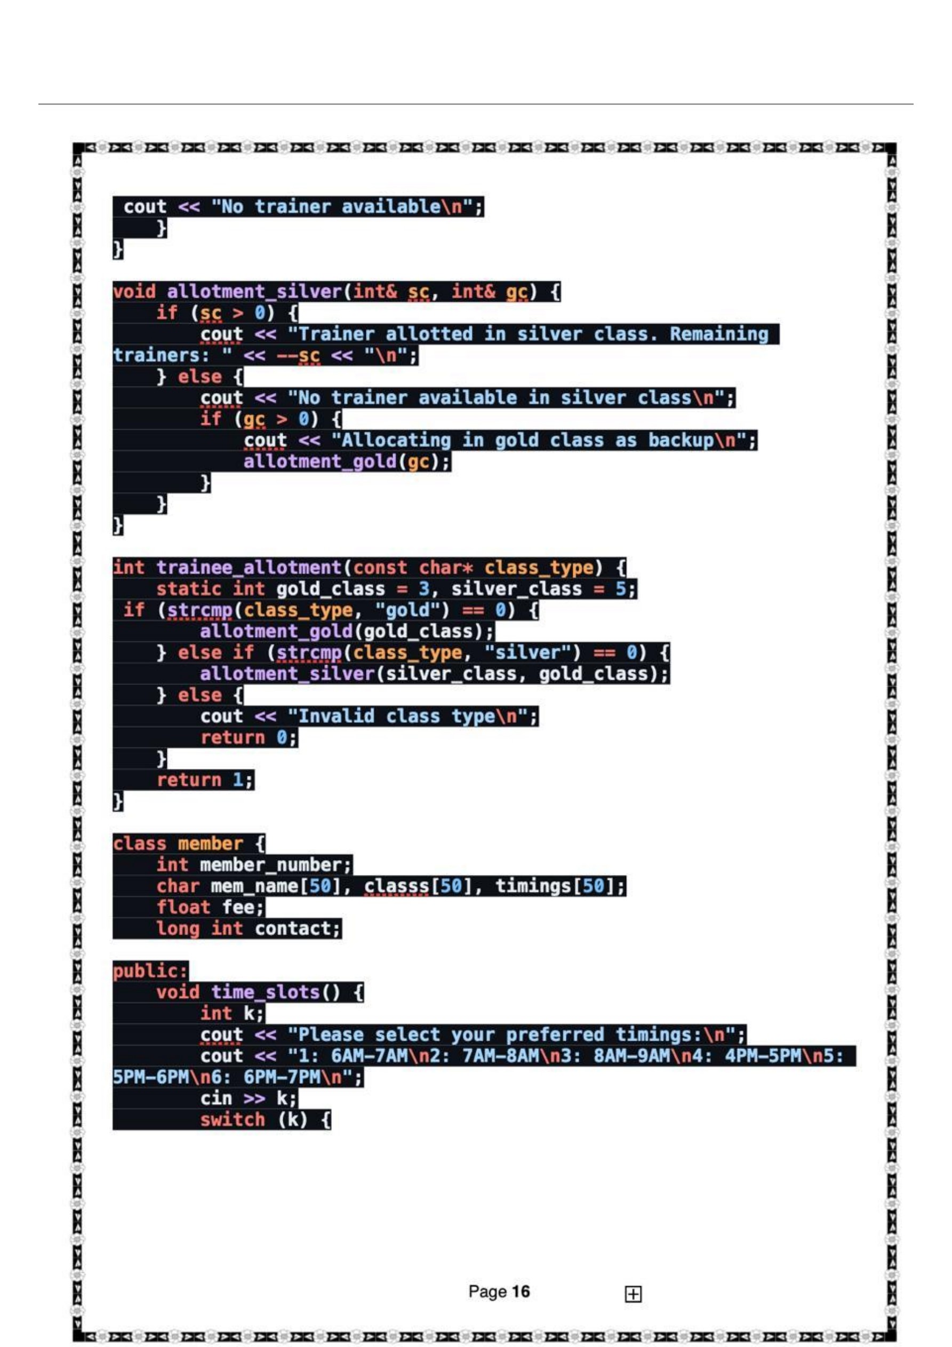

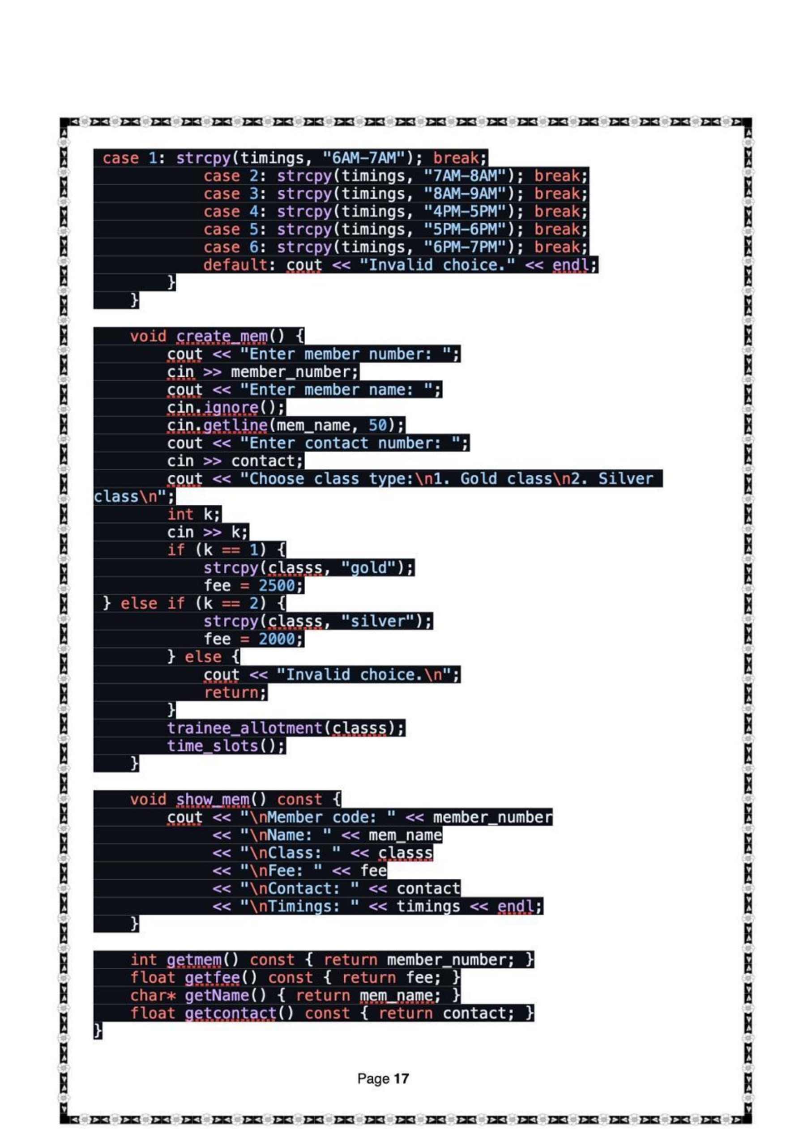

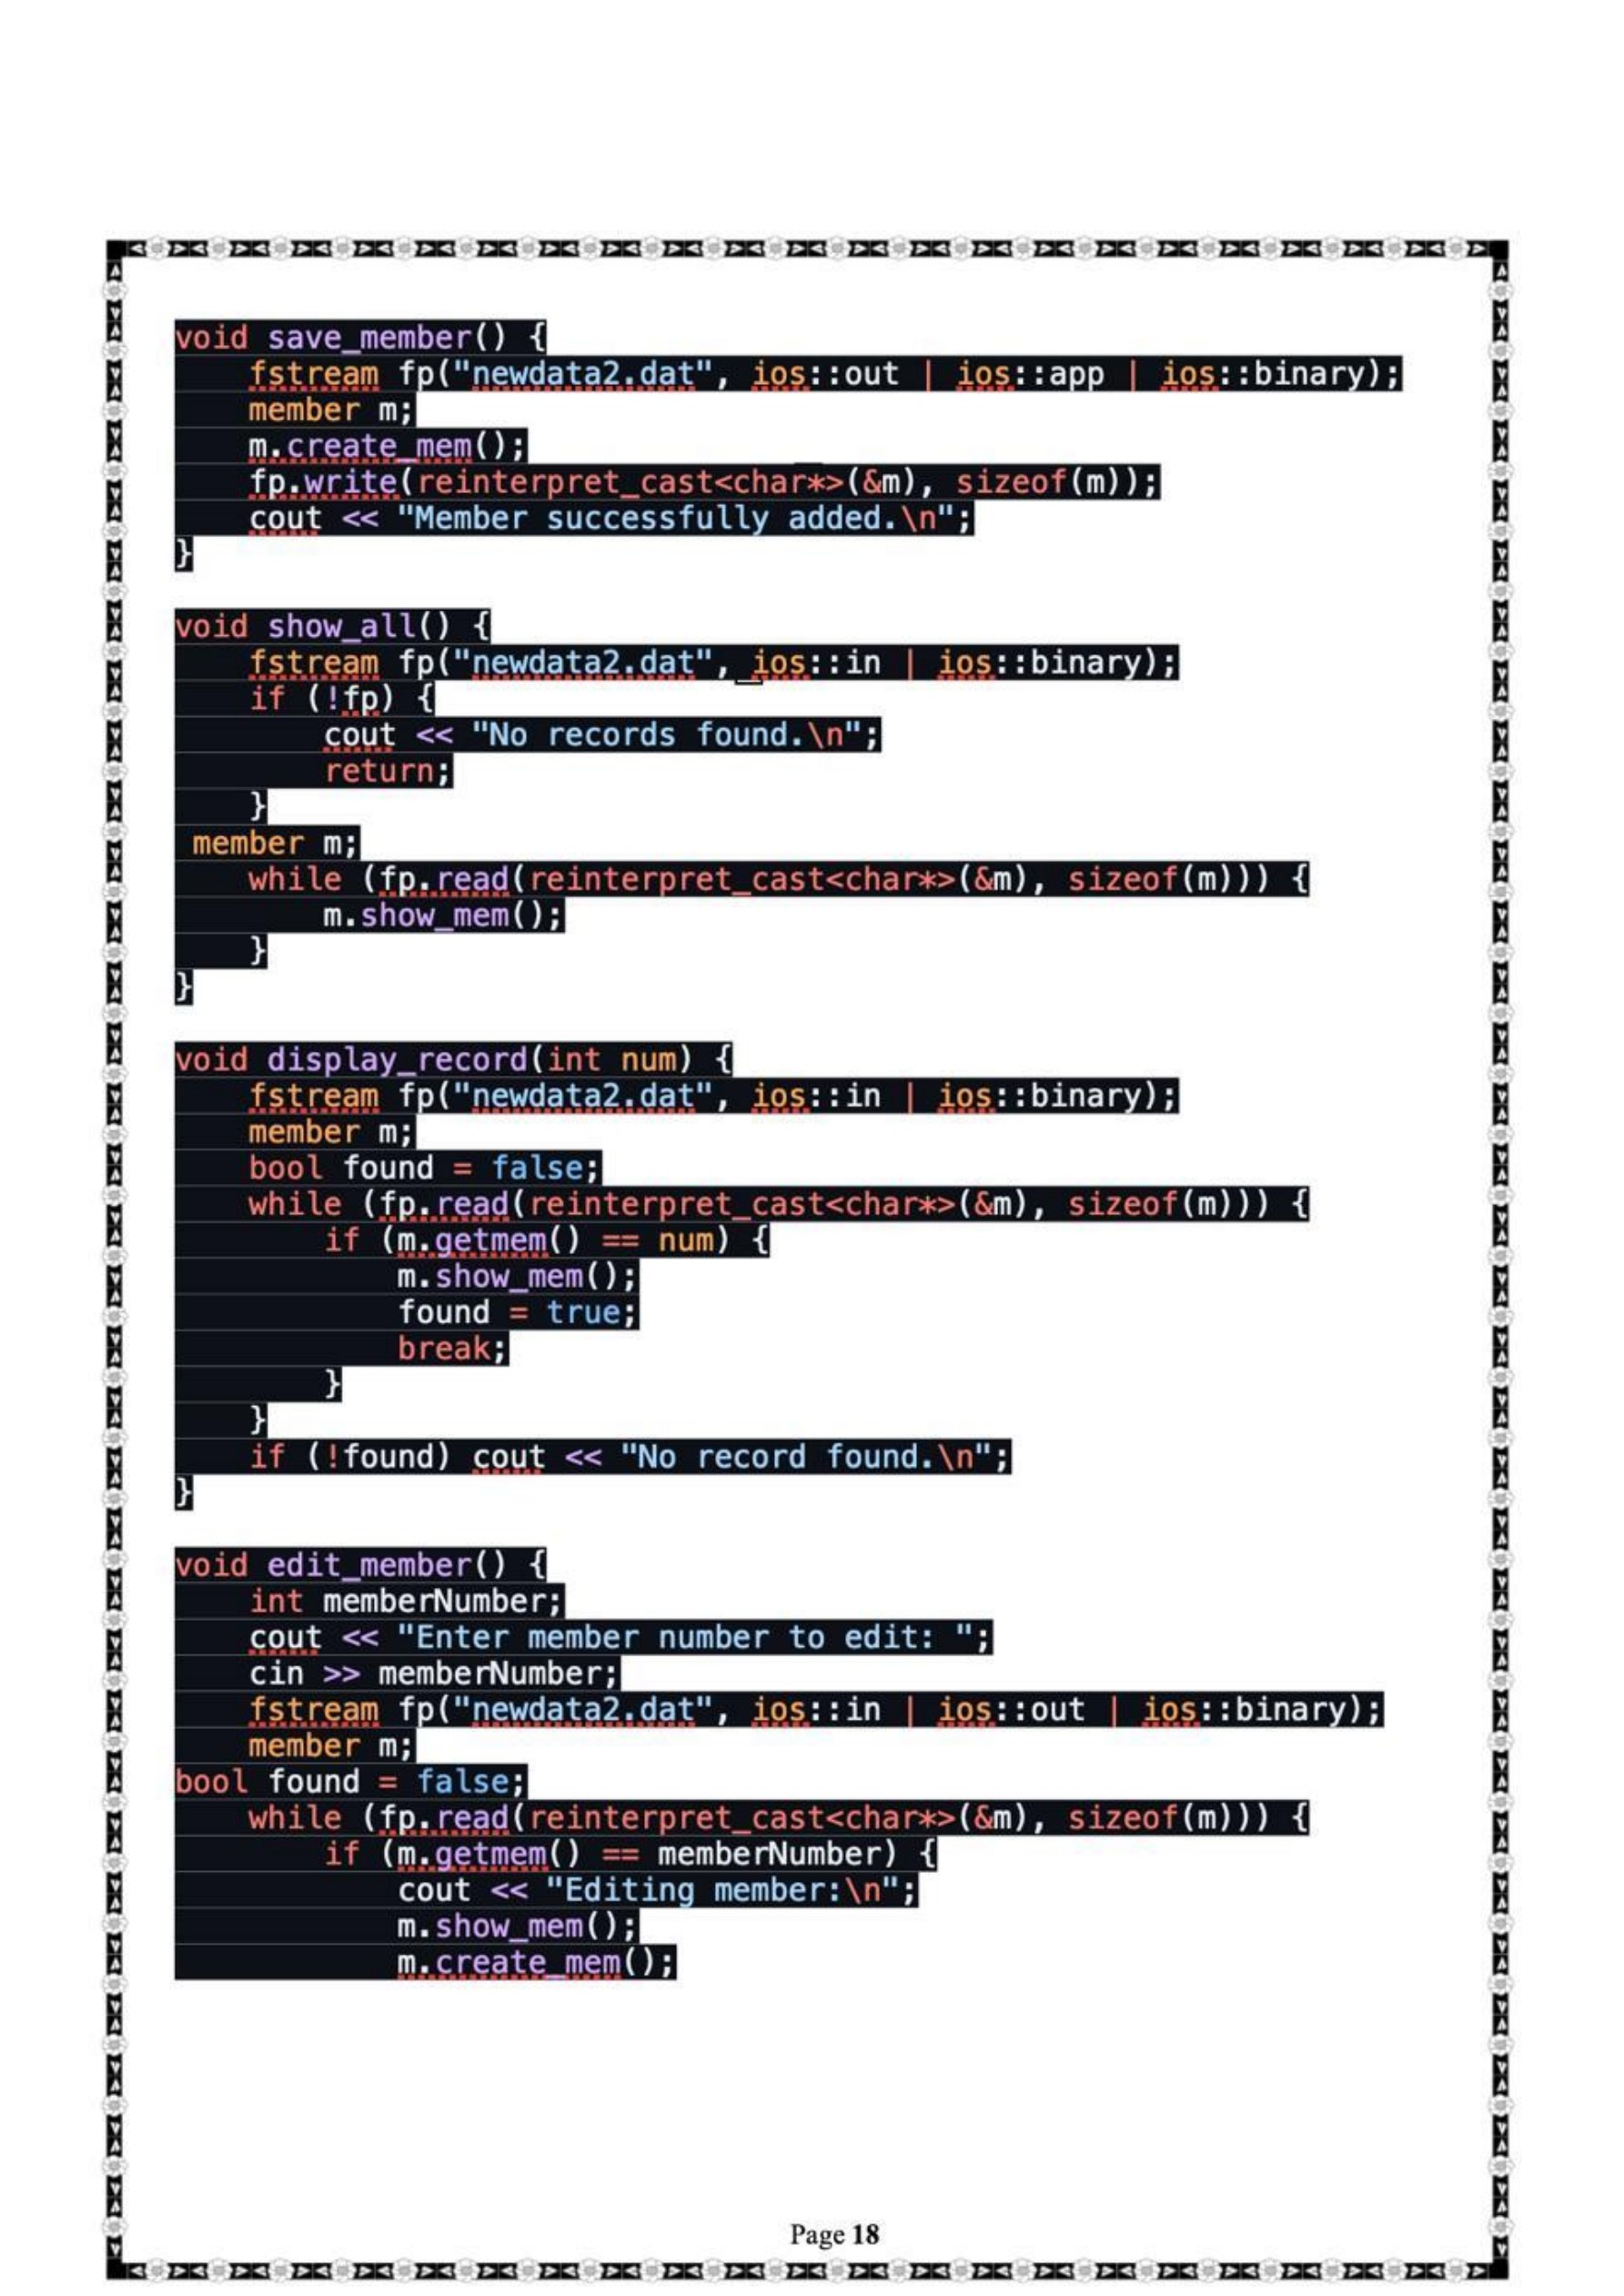

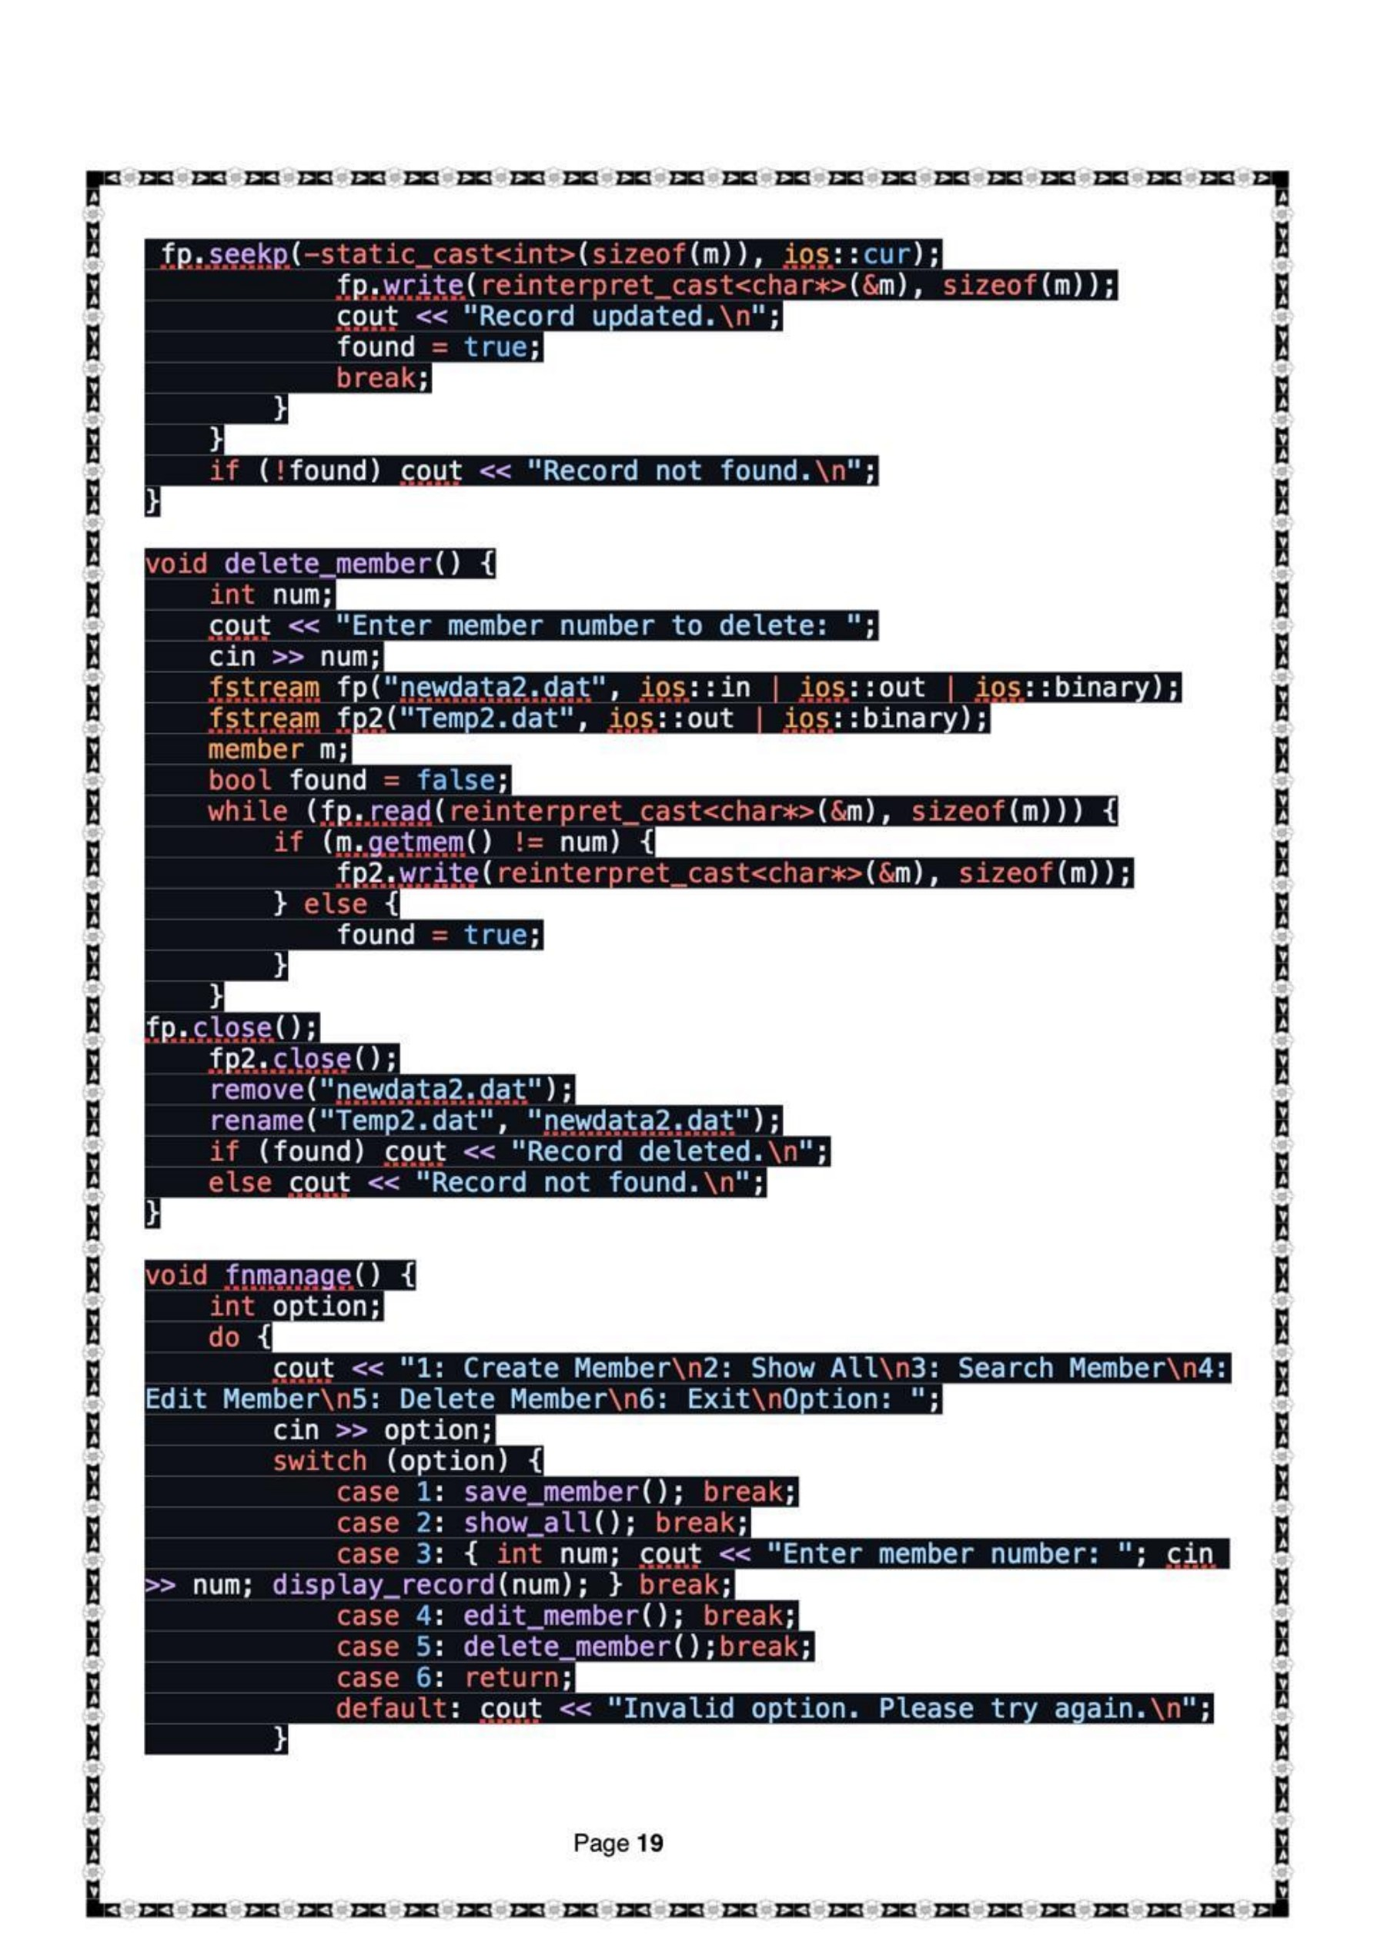

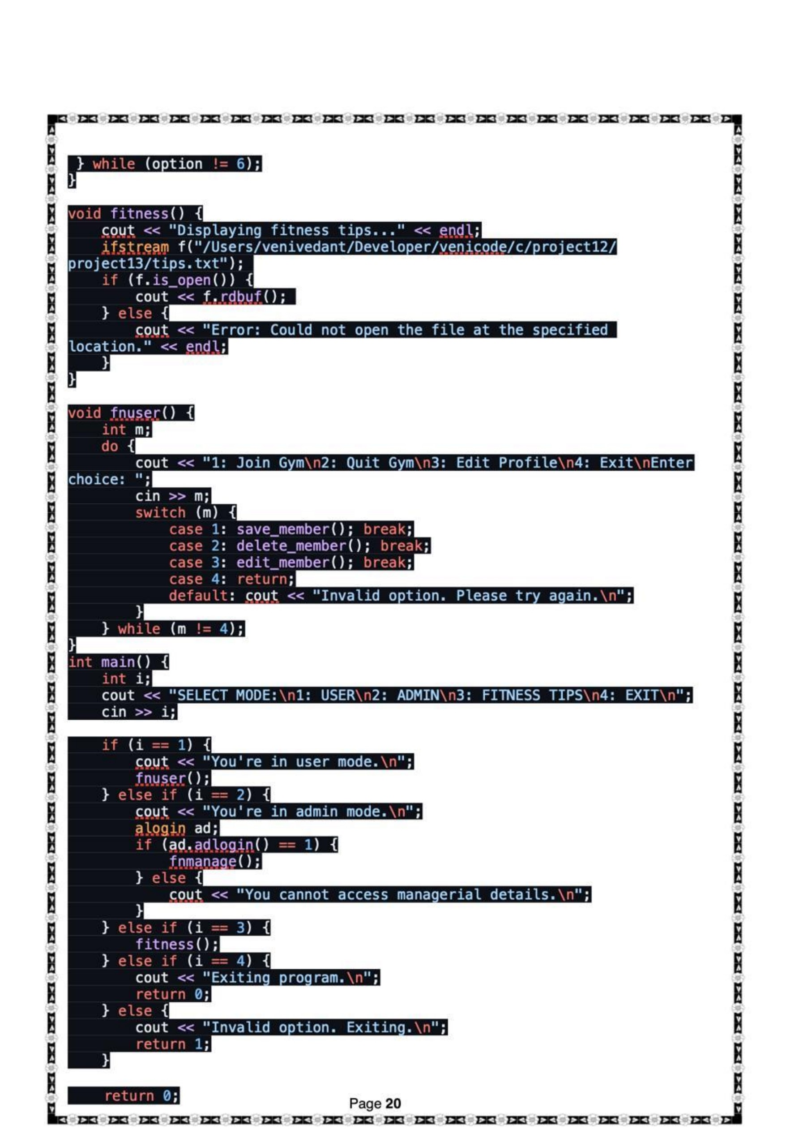

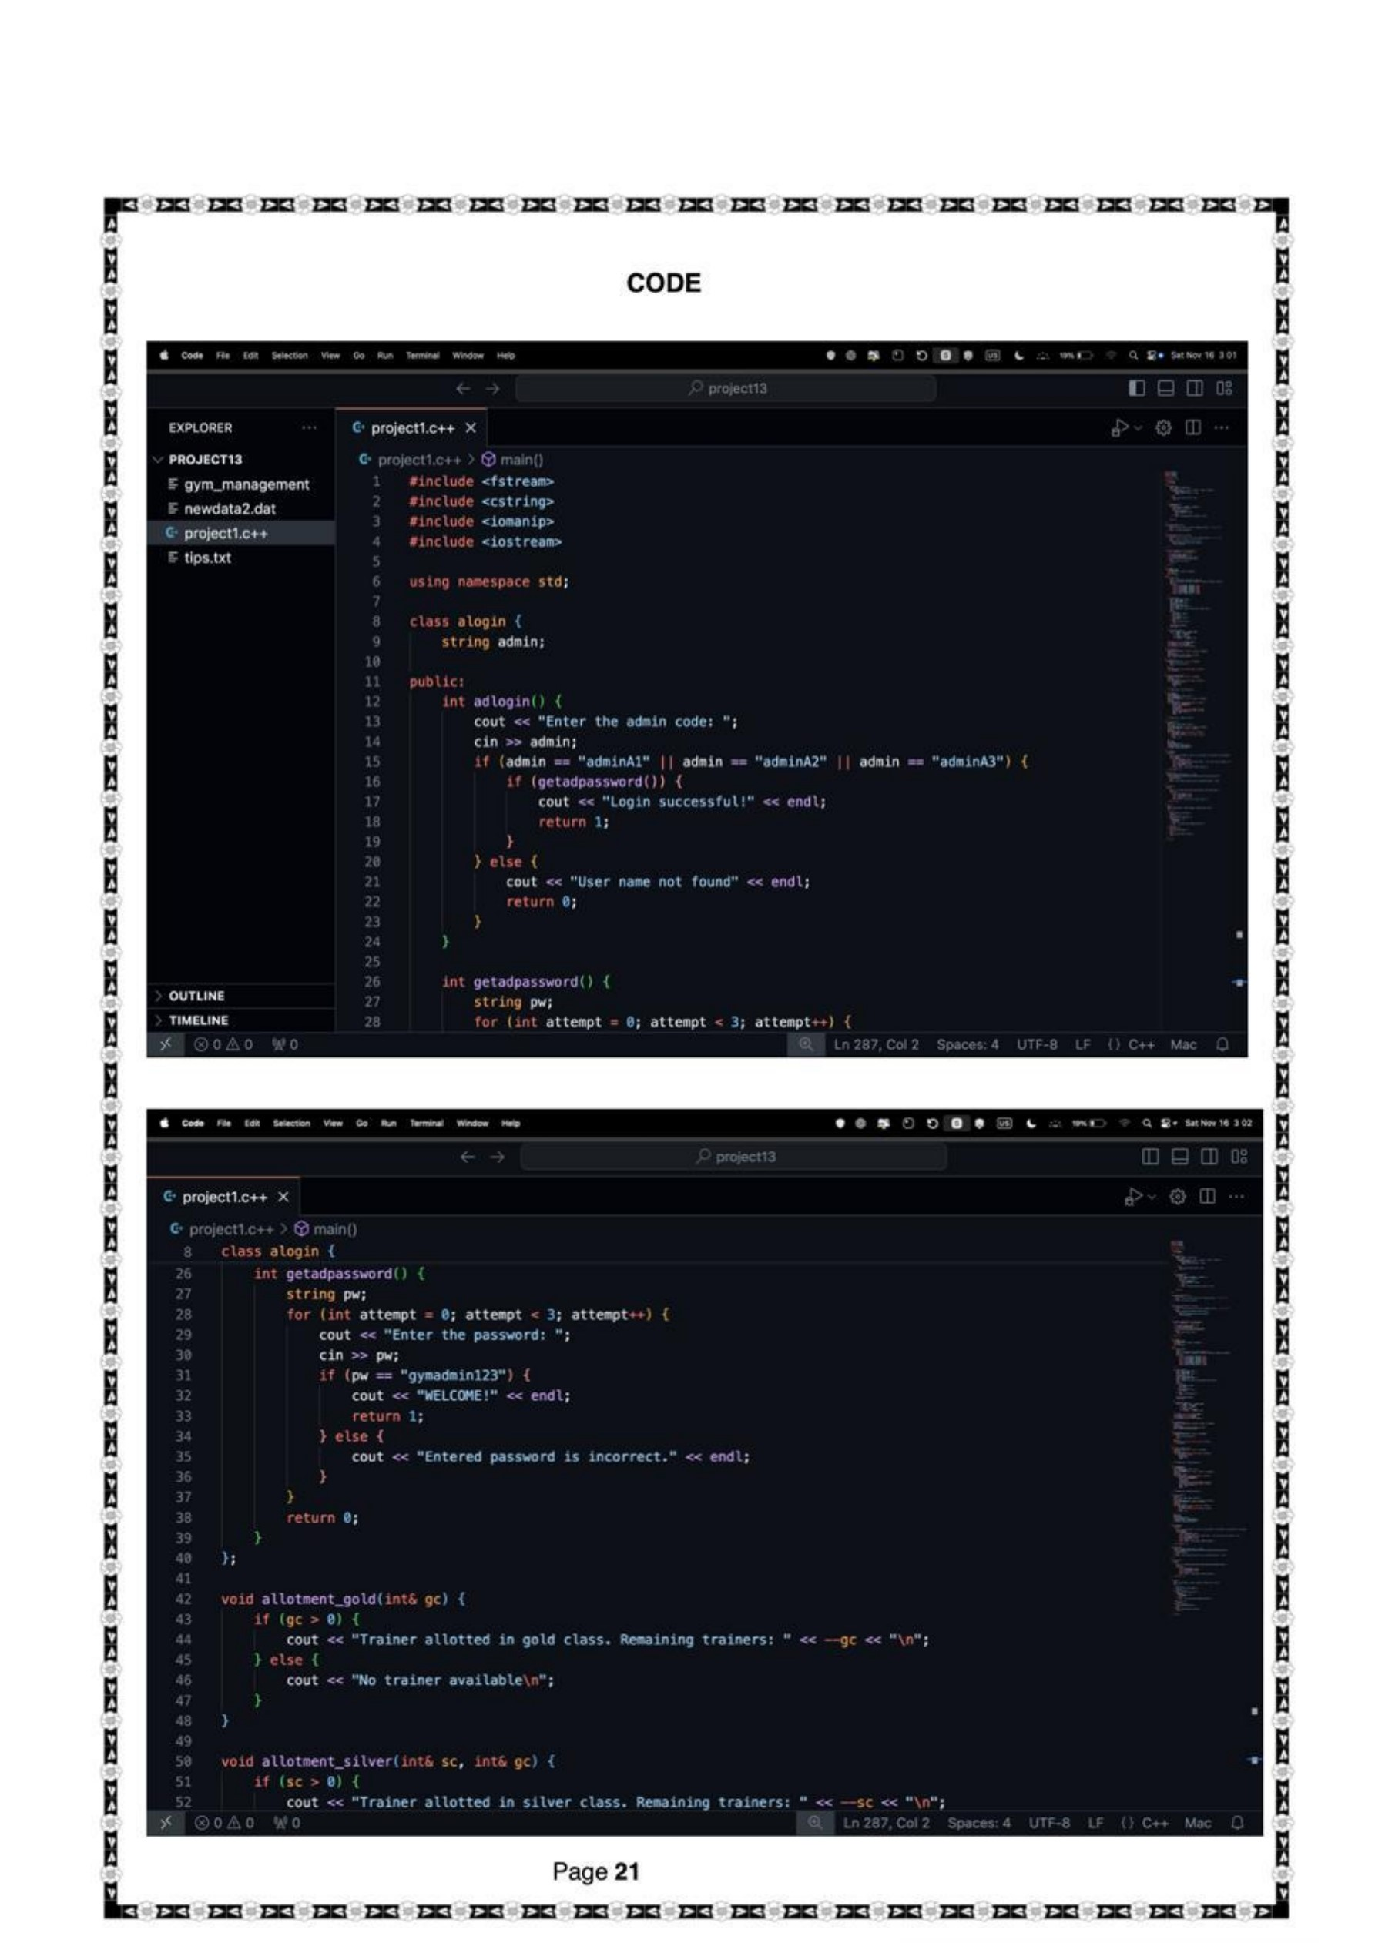

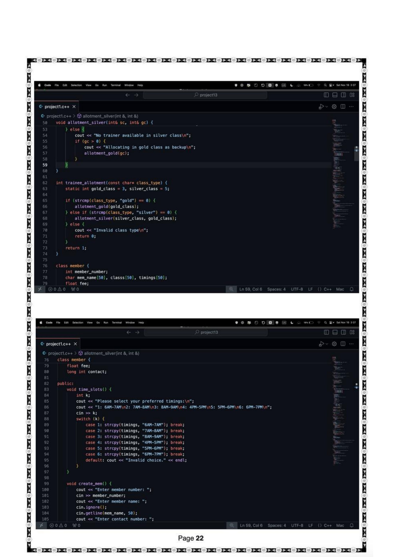

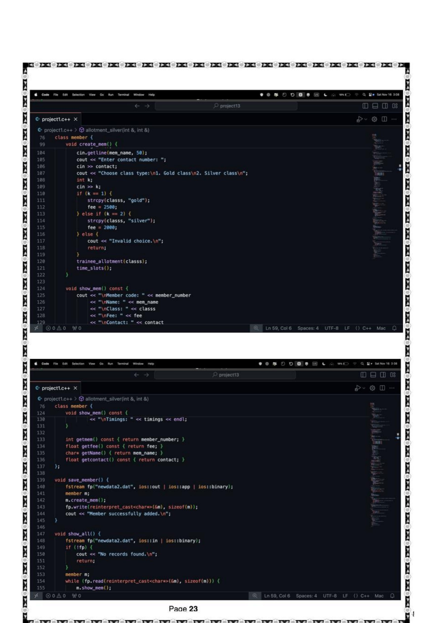

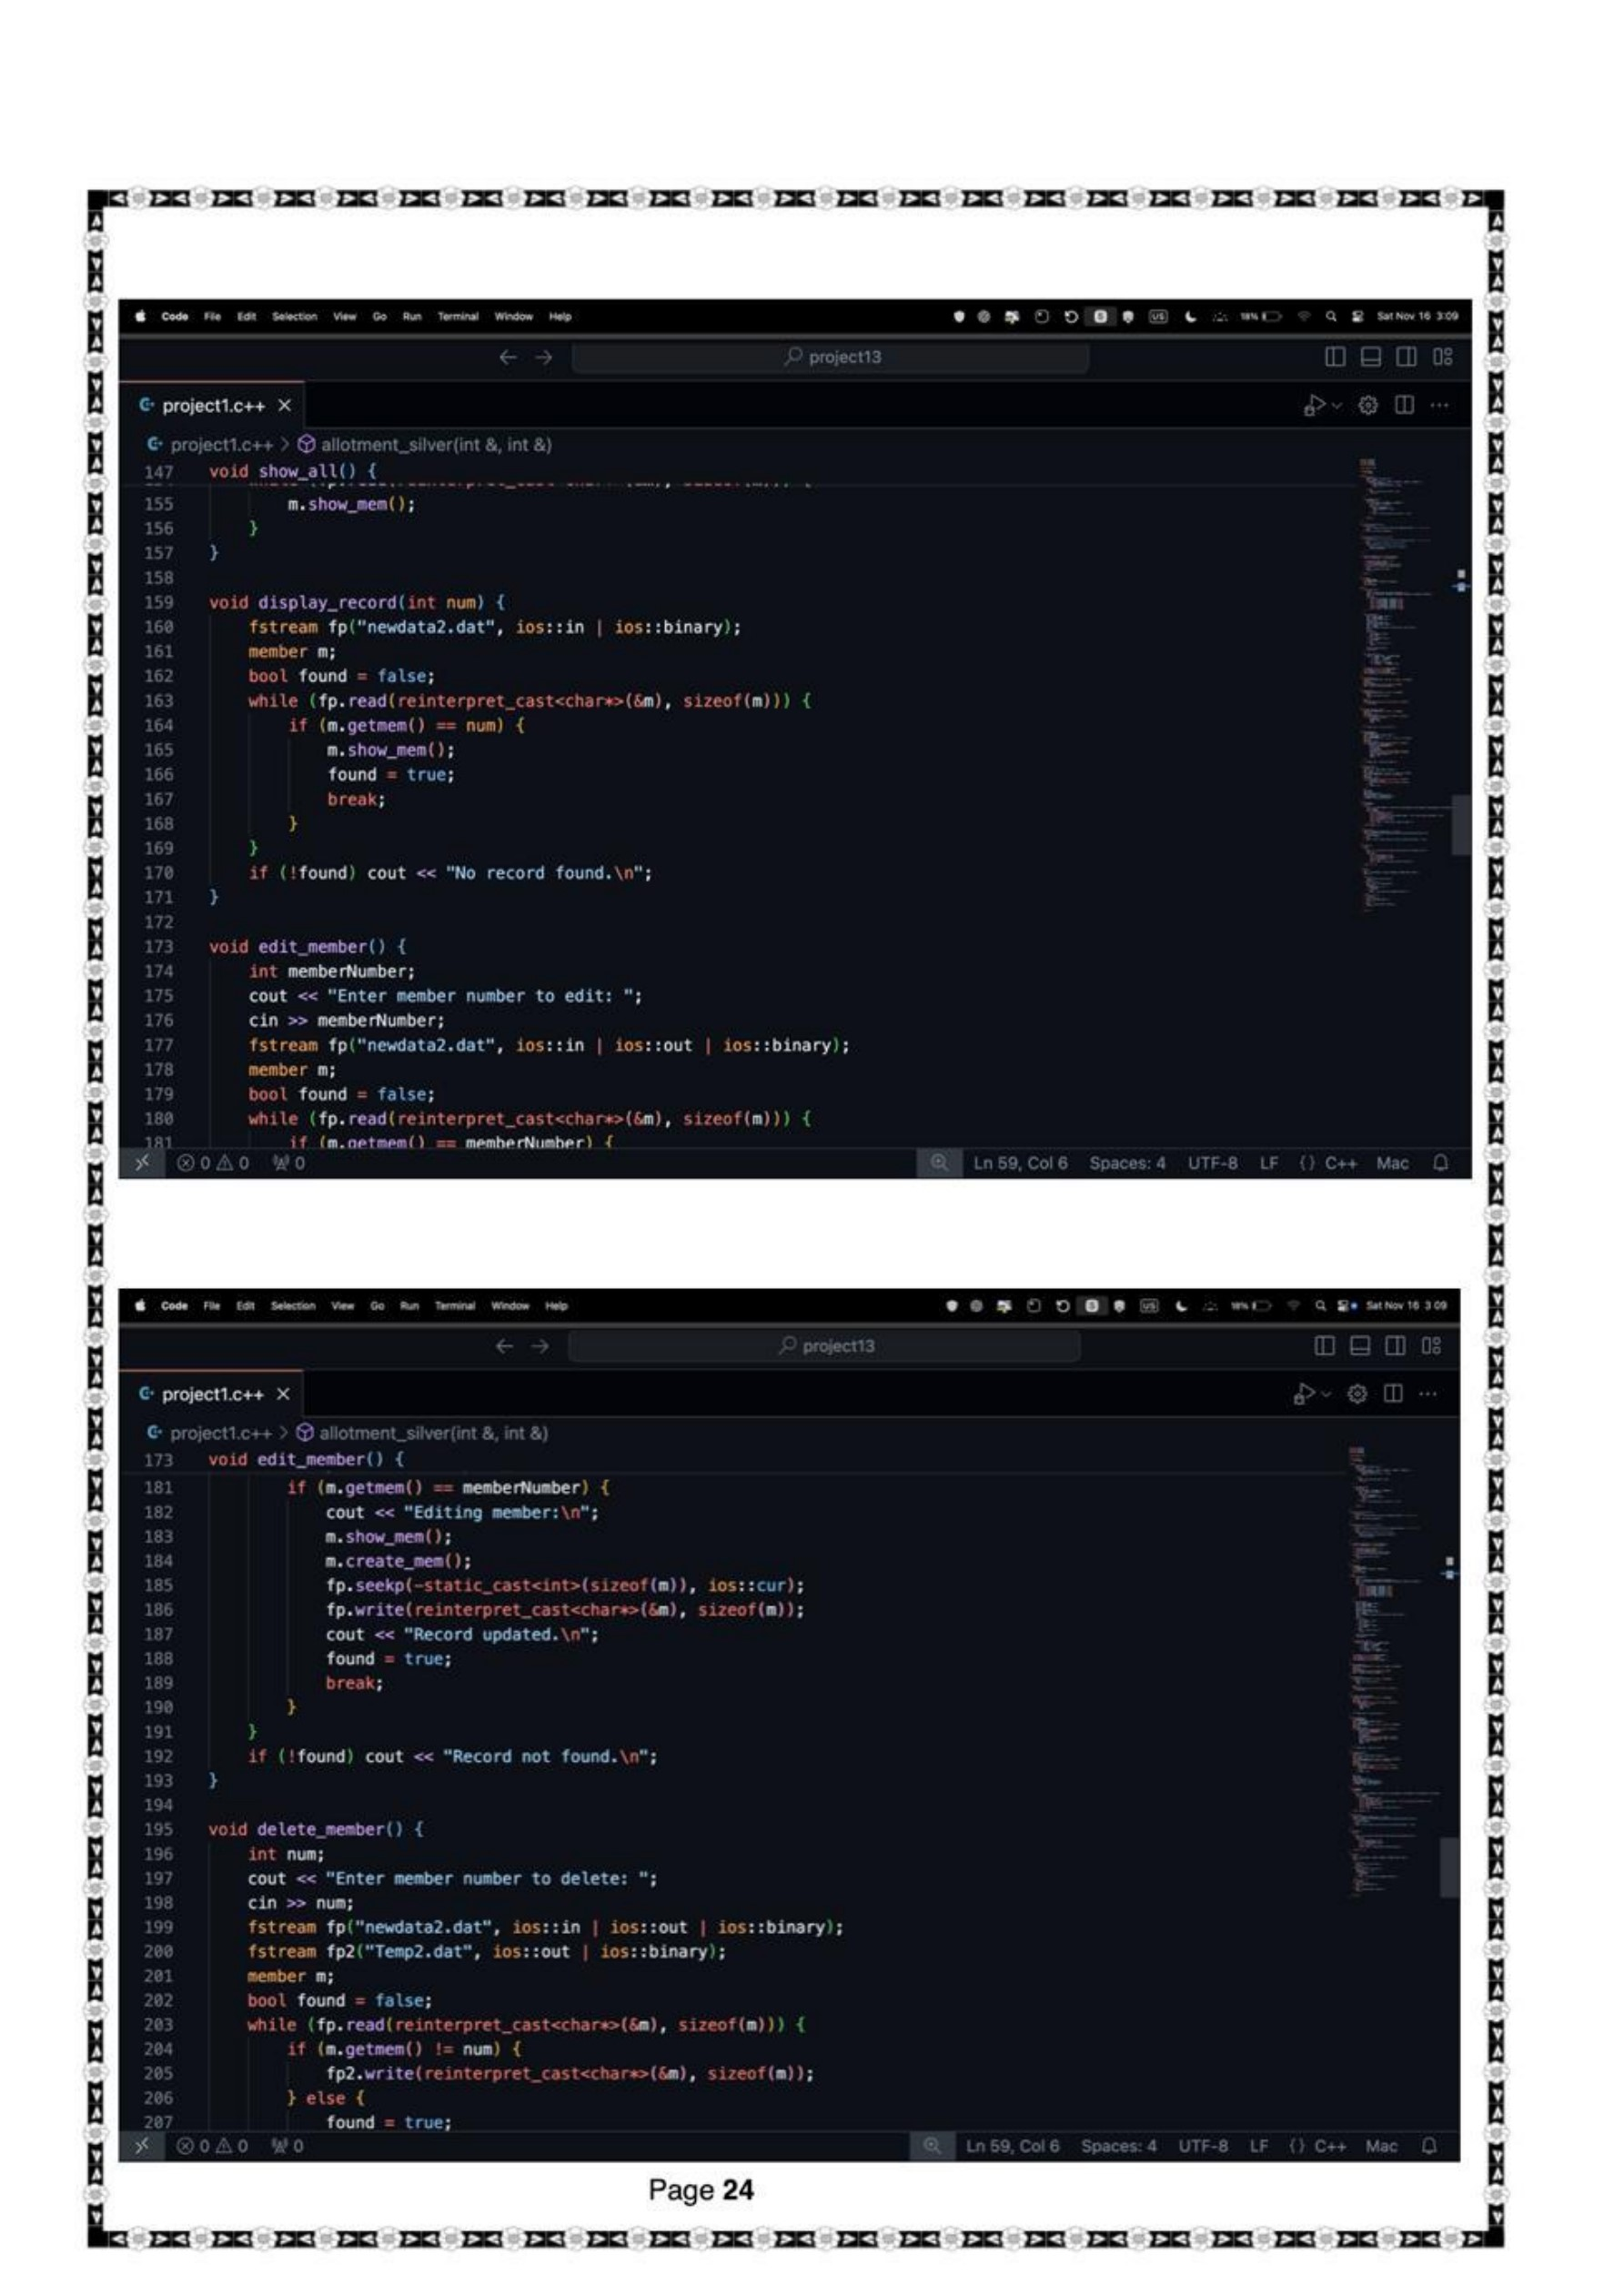

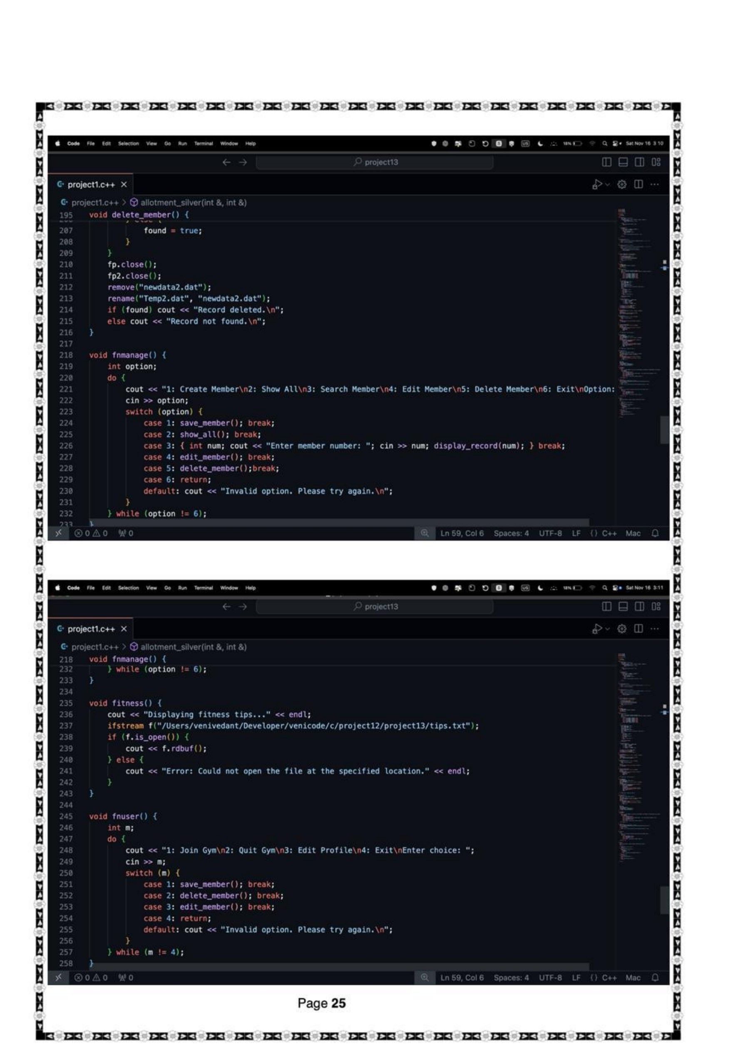

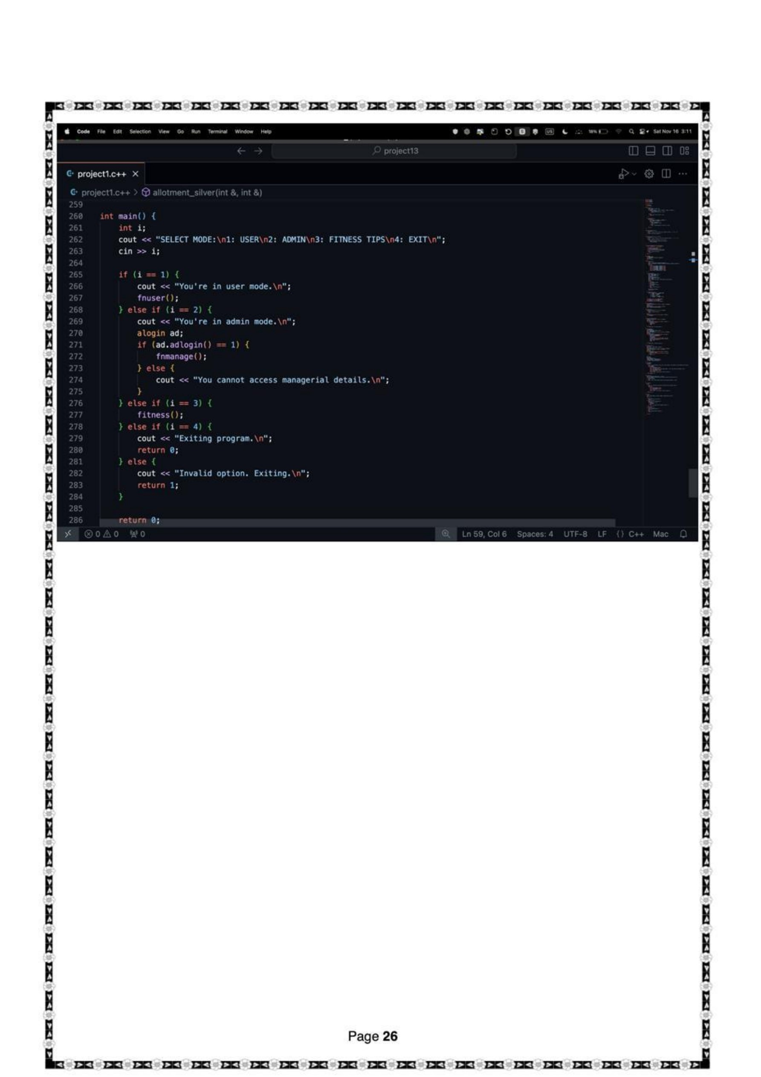

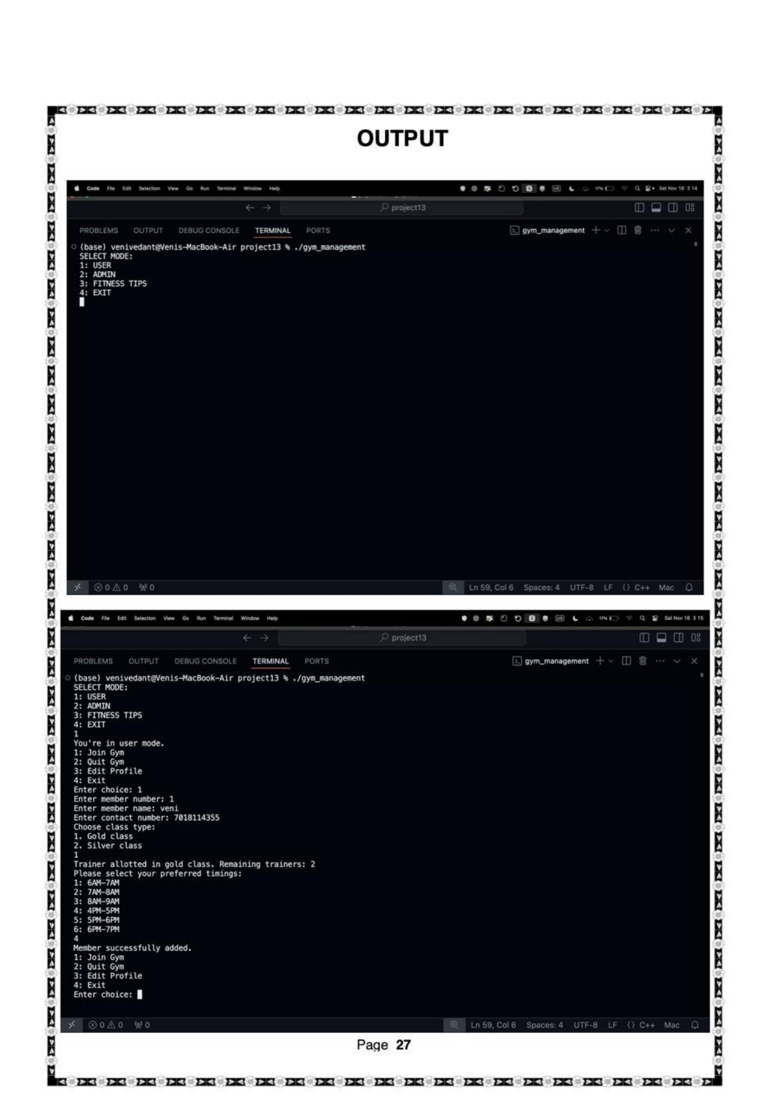

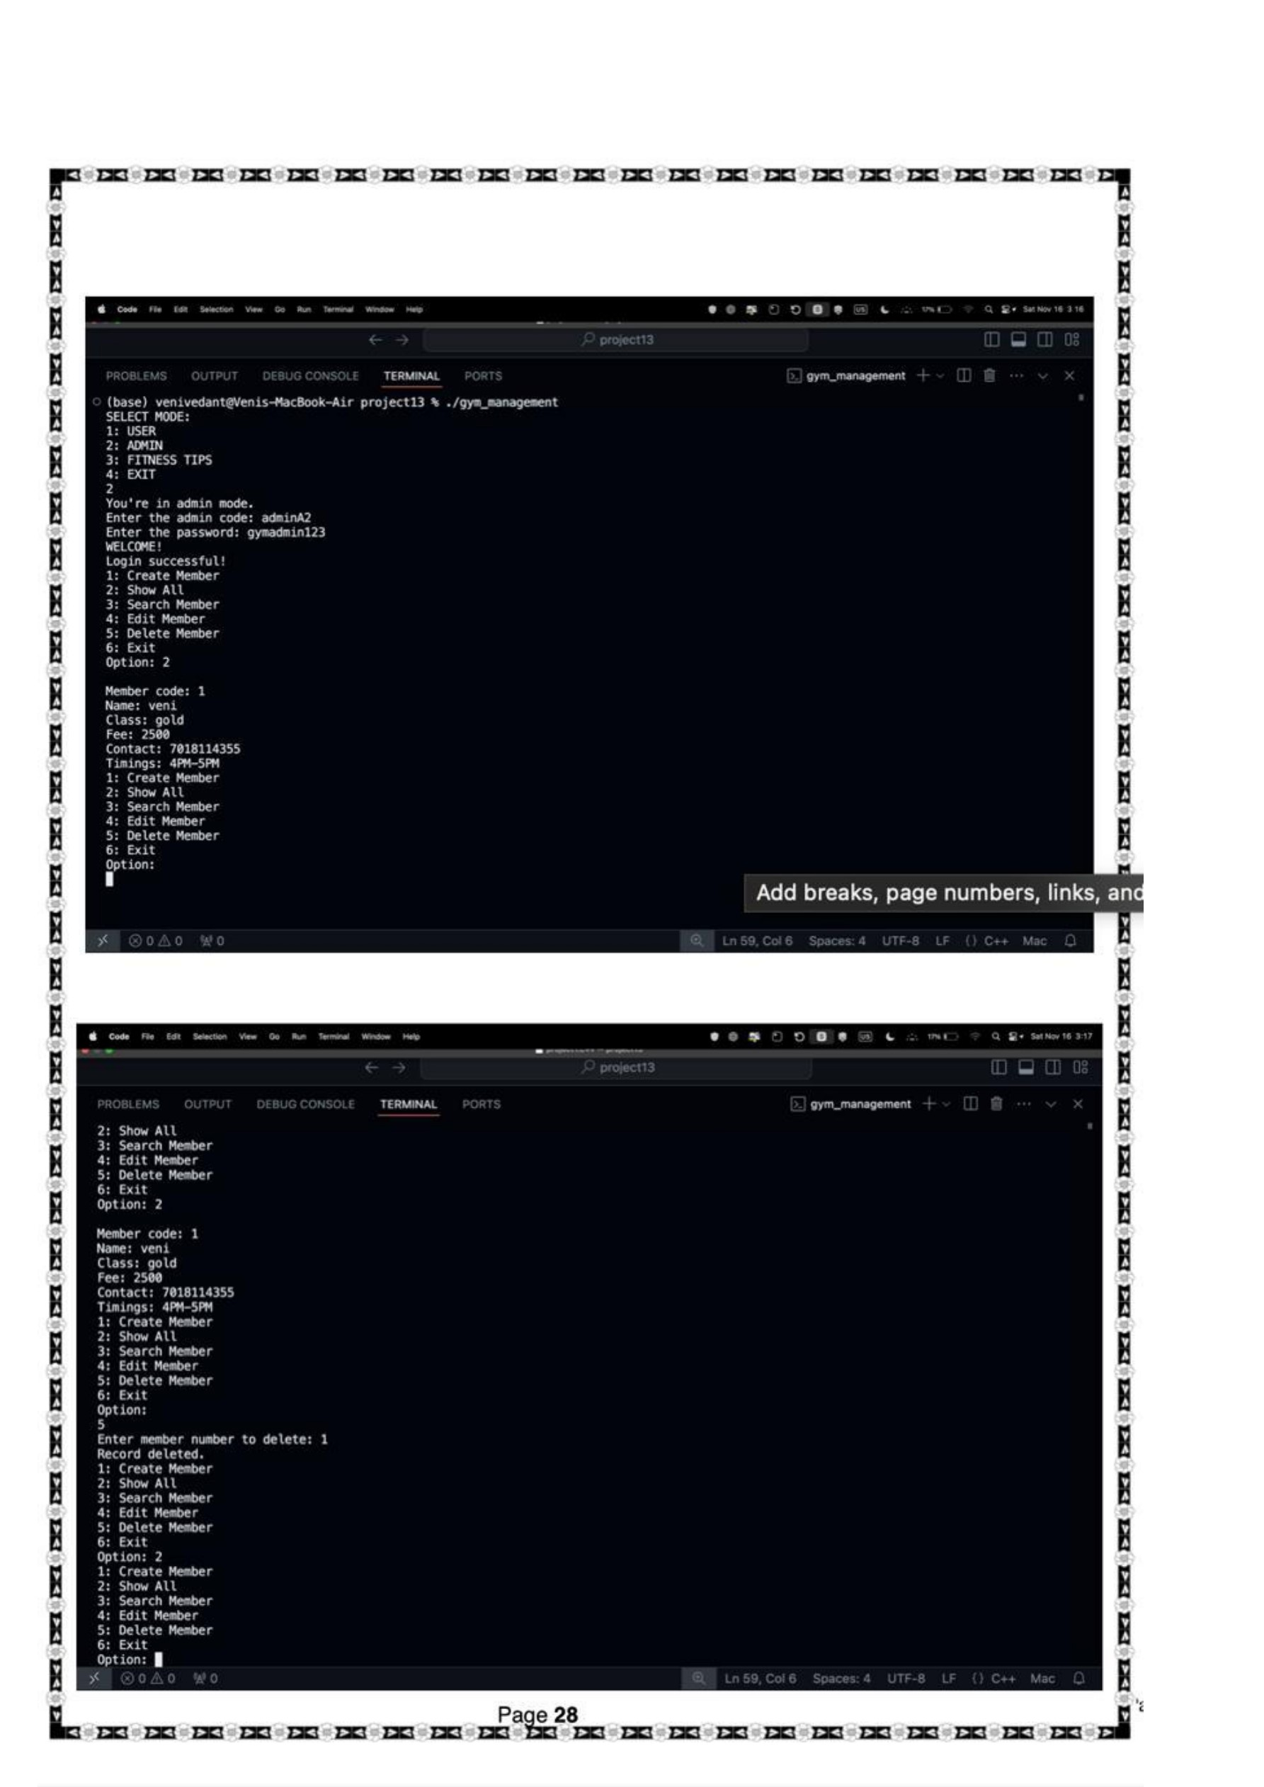

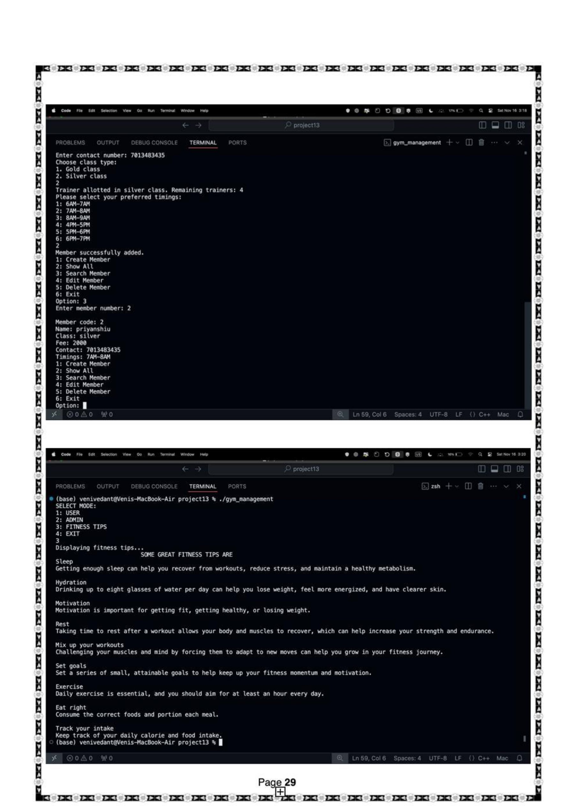

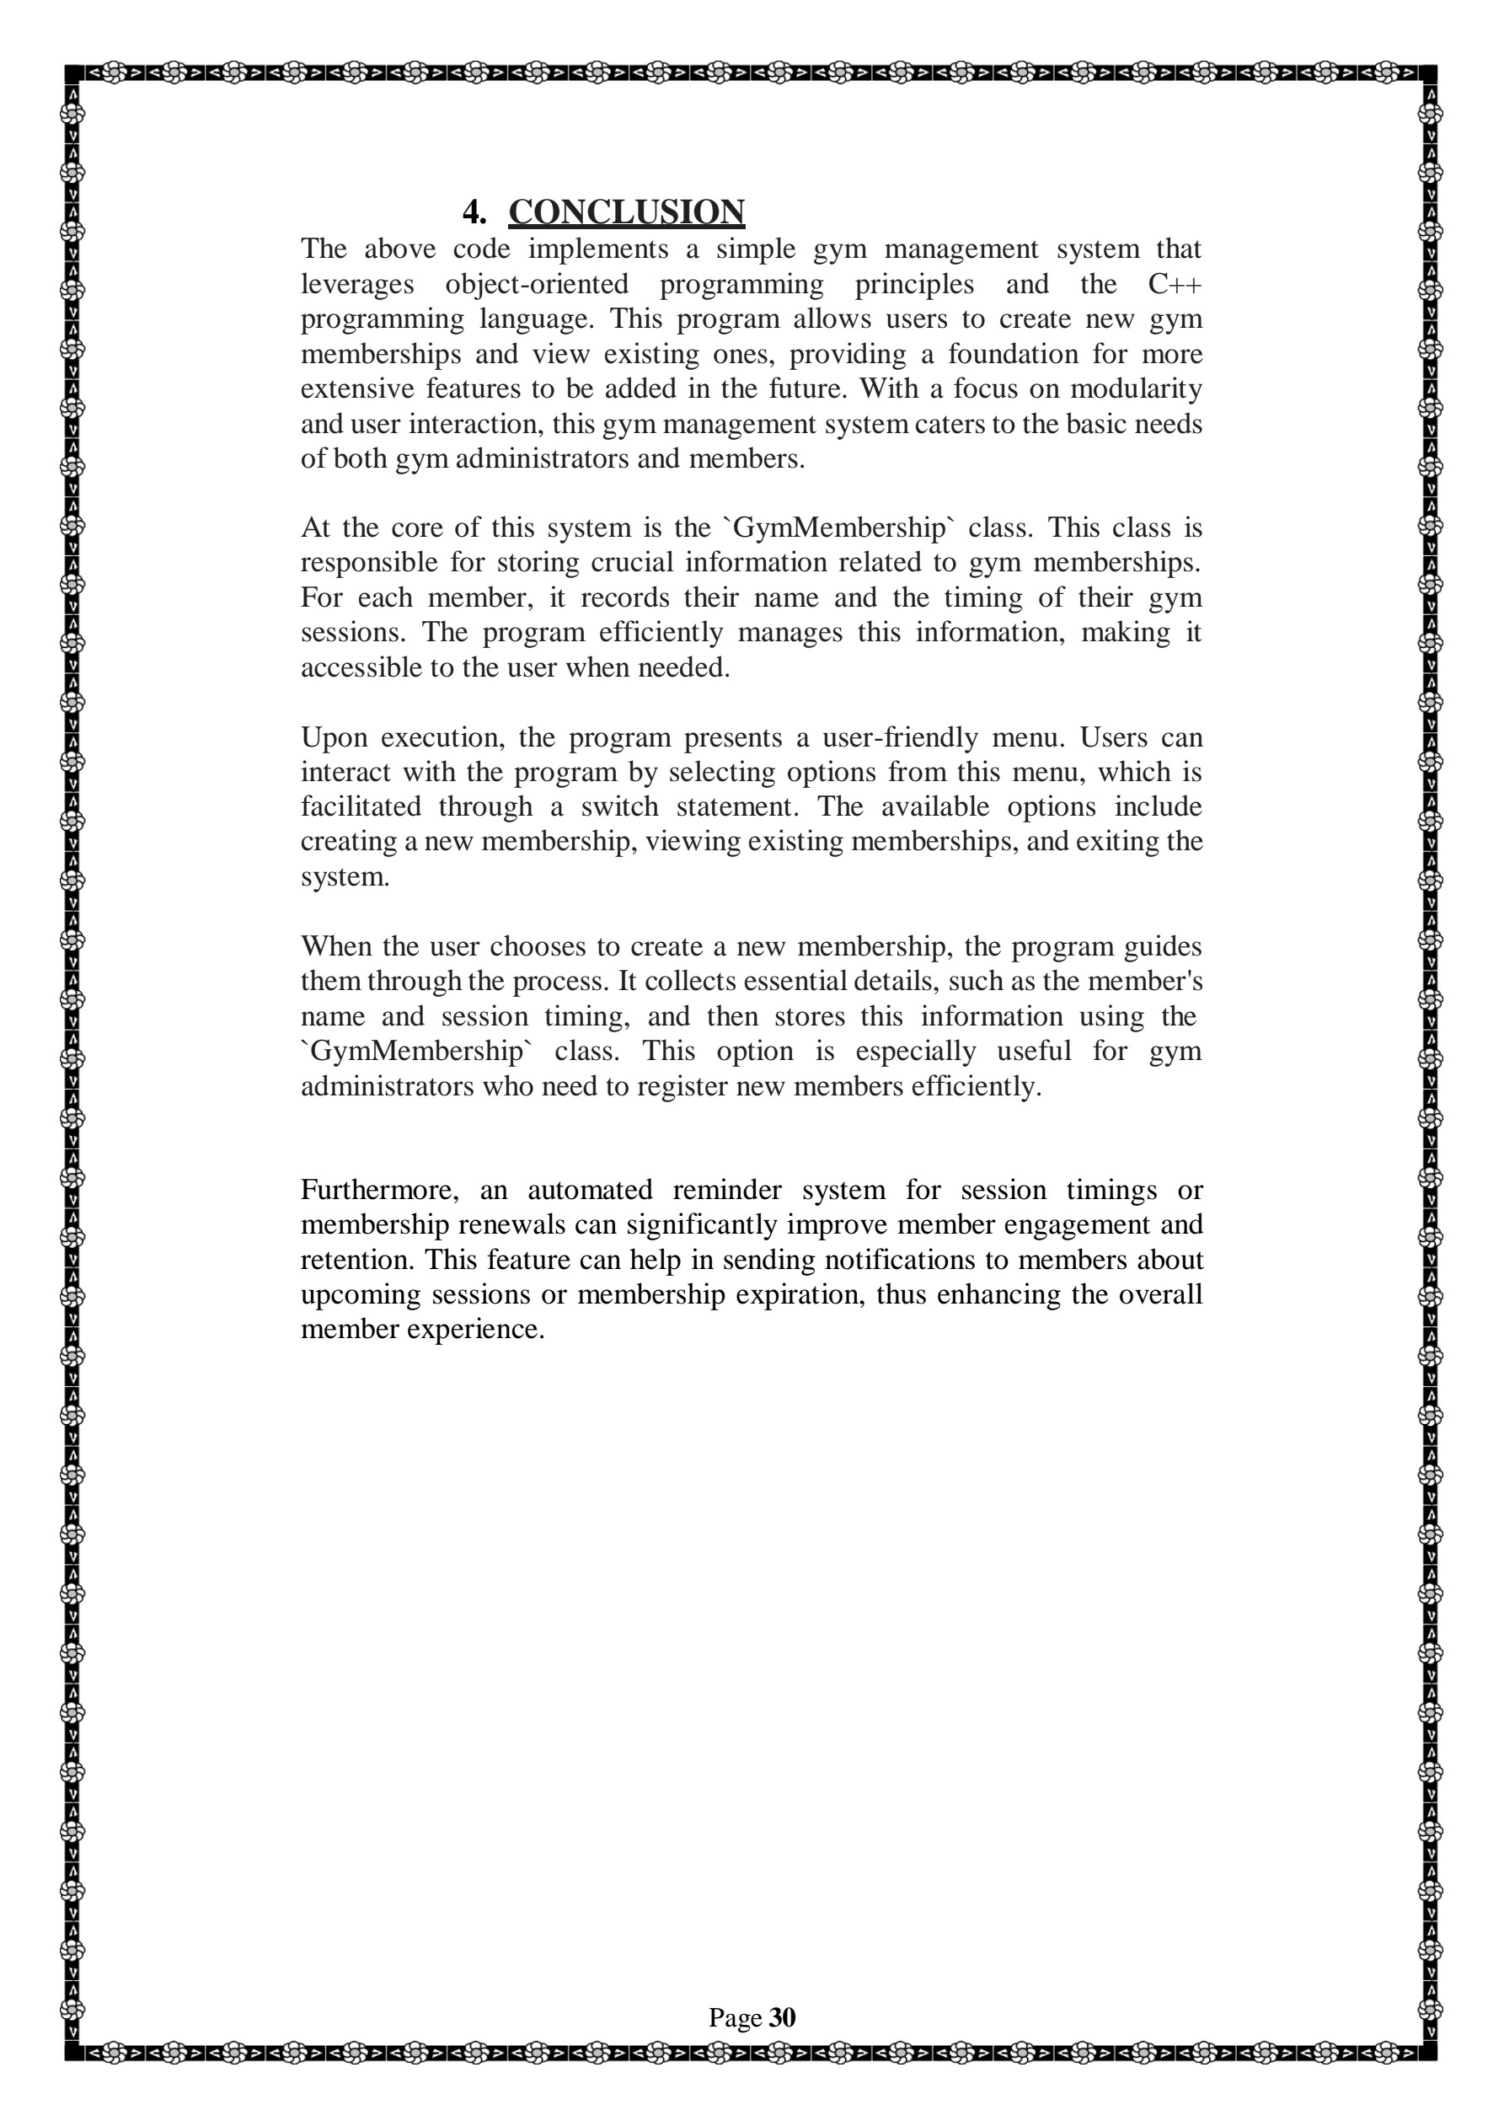

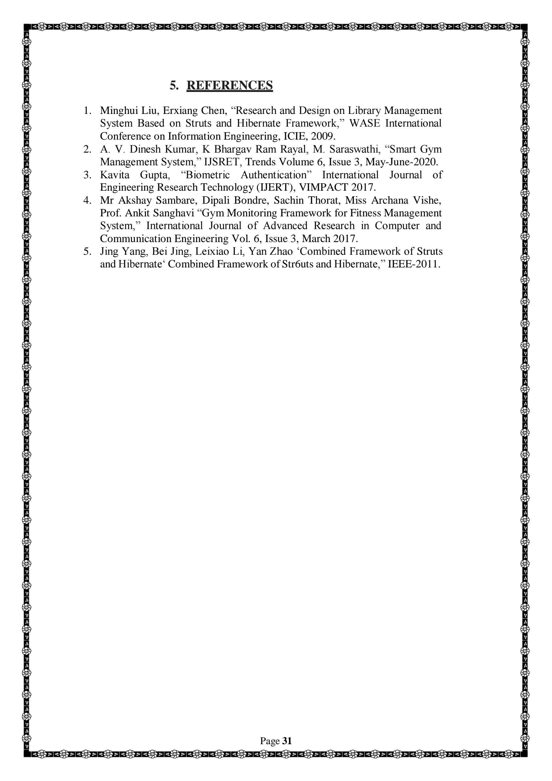

**SYNOPSIS 1**

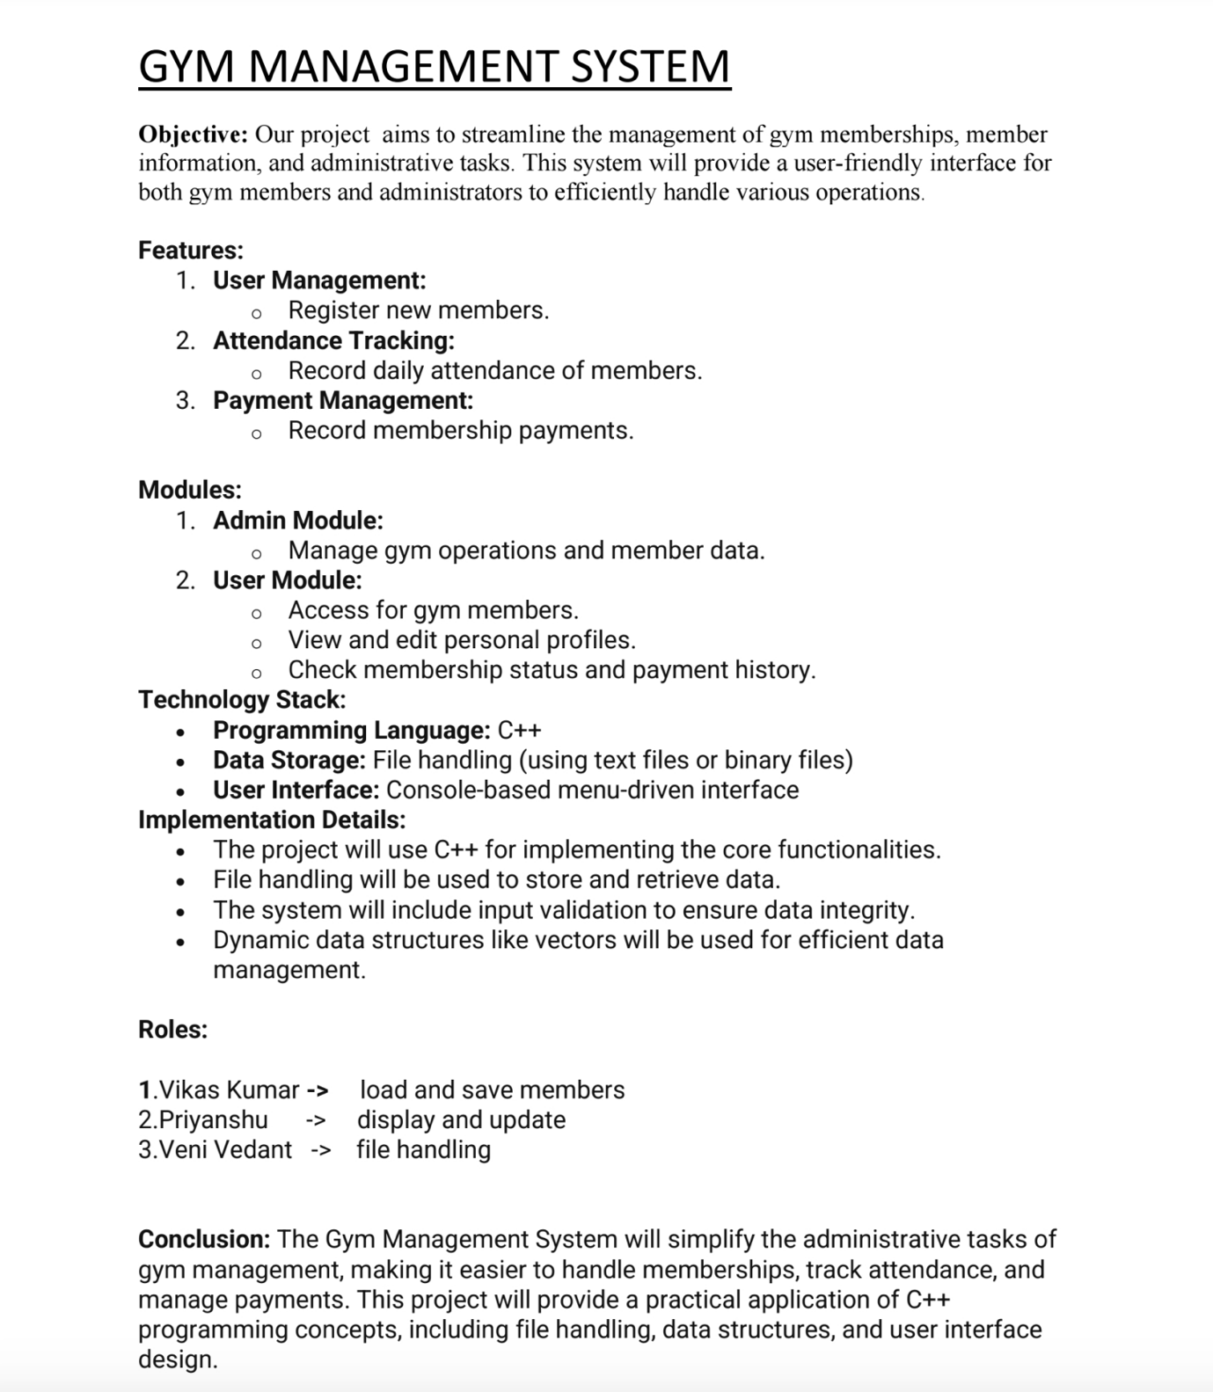

**SYNOSPSIS 2**

**INTRODUCTION**

**GYM MANAGEMENT SYSTEM**

The Gym Management System is a software application developed in C++ that aims to streamline the day-to-day operations of a gym. This system provides an efficient platform for managing member details, workout schedules, membership plans, and payment records, all while reducing manual workload and errors.

The project is divided into several modules, including member registration, login functionality for both staff and members, class and schedule management, and financial tracking. The system supports CRUD (Create, Read, Update, Delete) operations to manage gym members and services. It also features robust data handling to ensure the smooth operation of gym activities, allowing both the management and members to have easy access to necessary information.

**REVIEW**

At this stage, half of the project is complete, which includes:

1. **Member Registration and Login Module:** This module allows members to sign up, log in, and access their profiles. It also includes basic validation and error-handling mechanisms.

2. **Membership Plan Management:** The system currently supports multiple membership plans, allowing for additions, deletions, and modifications of plan details.

3. **Class/Workout Schedule Management:** This module tracks available classes, assigns trainers, and manages member bookings.

**OBJECTIVE**

The primary objective of the Gym Management System is to develop an efficient, user-friendly software application using

C++ that automates and simplifies the core management tasks of a gym. This system aims to streamline the process of managing member details, class schedules, memberships, and financial records. It seeks to enhance overall operational efficiency by reducing manual errors, improving data accessibility, and providing management with insightful analytics to optimize gym operations. Through this project, the system will ensure a smooth and organized workflow for both gym staff and members, improving their experience and satisfaction.

**METHODOLOGY**

The development of the Gym Management System follows a structured approach using the **Waterfall Model**, which ensures a clear, step-by-step progression through the various phases of the project. The project is being implemented in C++, utilizing object-oriented programming principles to create a modular, maintainable, and scalable solution.

**1.** **Requirement Analysis:**

The first step involved gathering and analyzing the requirements of a typical gym management system. This phase defined the core functionalities, such as member registration, workout scheduling, membership management, and payment processing. A clear understanding of user roles (e.g., gym staff, trainers, and members) and their interactions with the system was established.

**2.** **System Design:**

The system architecture was designed based on the requirements. Key components and modules such as member management, login system, class scheduling, and membership plans were identified. The design also focused on implementing CRUD (Create, Read, Update, Delete) operations for data management. UML diagrams, such as class diagrams and use case diagrams, were used to visualize the system’s structure and behavior.

**3.** **Implementation:**

The project is being implemented in **C++** with a modular, object-oriented approach. Each functional module, such as Member Management and Schedule Management, is being implemented independently.

Half of the project is complete, covering:

• Member registration and login functionality.

• Membership plan management (add, modify, delete plans).

• Class and workout scheduling, including trainer assignments.

Key data structures such as arrays, linked lists, or vectors are being used to store and manipulate information efficiently.

**4.** **Testing:**

Throughout the development process, each module undergoes unit testing to ensure correct functionality and handle exceptions. The system is tested for errors, invalid inputs, and performance bottlenecks. Integration testing will be conducted once the remaining modules (such as payment management and report generation) are developed.

**5.** **Data Storage:**

Member details, schedules, and plans are stored in text files, ensuring persistence across sessions. File I/O operations in C++ are used to read, write, and update data files. The system design allows for the potential transition to more advanced database solutions in future iterations.

**6. User Interface:**

A simple, text-based user interface is used to interact with the system, allowing gym staff and members to navigate through options, view information, and perform required actions. The interface prioritizes ease of use and clear navigation for users with varying levels of technical proficiency.

**7. Future Enhancements:**

After the completion of the core functionalities, further improvements will be made. Planned future modules include:

• Automated membership renewal reminders.

• Detailed financial tracking and payment history.

• Analytical reports on gym attendance and member activity.

By following this structured methodology, the project aims to deliver a robust and functional gym management system that meets the specified requirements.

**CONCLUSION**

The Gym Management System, developed using C++, is designed to streamline and automate the essential operations of a gym, improving overall efficiency and user experience. With the successful completion of key modules, such as member registration, login, class scheduling, and membership management, the system has made significant progress towards achieving its objectives. The implementation of a modular and object-oriented approach ensures that the system is scalable and maintainable. Upon completion of the remaining features, including financial tracking and reporting, the system will provide a comprehensive solution to modern gym management challenges, offering ease of use and improved operational efficiency for both gym staff and members.